Stem Cell Research Project
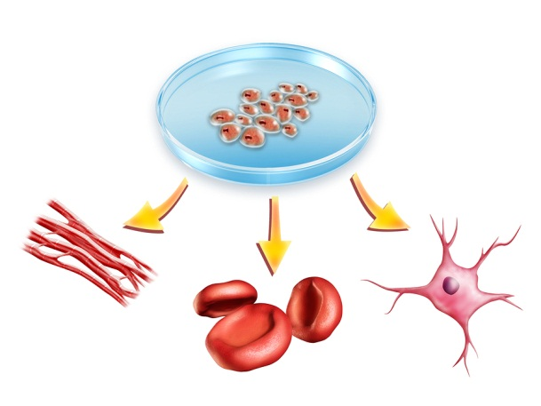
Year 8 Science – Cells
You are to work alone or with a partner to complete at least three of the activities below. At least one of the activities must be done alone and at least one must be done with a partner.
You will have one week of class time to work on your project. You are expected to spend at least an hour at home working on this project as well. If you don’t have access to the internet at home, then write your facts during class time and write your opinions or summaries at home. Be clever about using your time and the resources available to you.
Try to do as much of the work electronically as you can. Send me your files as you complete them – make it clear in the naming of the files whether you have worked with a partner or not
Eg stem cell ethics peter and sue.docx
Activities (choose at least three)
Stem Cell Research Grid summarise answers to basic questions (good to start on)
Stem Cell Media Article Review choose and read newspaper article online and summarise
Stem Cell Video Review choose and watch video online and summarise
Stem Cell Ethics For and Against summarise the reasons why some people are upset about stem cells
Stem Cell Health Problem choose and research some questions on a health problem that might be treated using stem cells
The questions are all to be found in the attached pages.

Assessment Criteria
- Effort on work in class
- Number of activities completed
- Accuracy of facts and ideas quoted
- Reasoning for your opinions given
- Spelling and grammar accurate
- Presentation of documents
My email address: oates.matthew.v@edumail.vic.gov.au

