10.3 Explaining the properties of water
- Water is not a typical liquid, it properties are unusual.
- We need to look at its structure and bonding.
- Water is described as a covalent molecular compound, with a molecular formula of H₂O.
- The oxygen – hydrogen bonds are polar, with the oxygen atom having the larger share of electrons due to its higher electronegativity.
- The forces between water molecules are hydrogen bonds, which are relatively strong when compared to other types of intermolecular bonds.
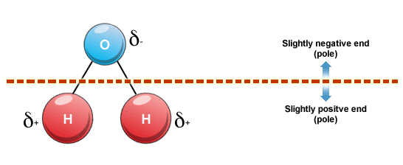
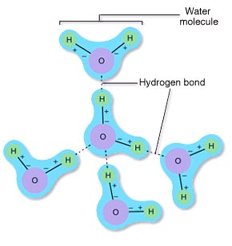
- The polarity of the oxygen-hydrogen bonds and the hydrogen bonding between water molecules give water its unique properties.

Relatively High Melting and Boiling Temperatures
- Water is the only substance commonly found in all three states under the conditions normally found on earth.
- Figure 10.8
- Water exists as a liquid over a temperature range normally found on earth
- The melting and boiling temps of water are significantly higher than other molecules of similar size. (if only dispersion forces are present then molecules of similar size have similar boiling and melting temps)
- In solid water (ice) the molecules are arranged in a structured and regular manner
- Each molecule forming hydrogen bonds directly to four other molecules.
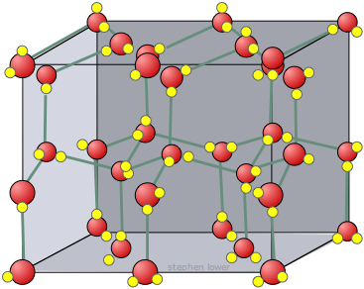

- For ice to melt energy must be provide to increase the kinetic energy to disrupt the crystal lattice. In the melting process some of the hydrogen bonds break free and the lattice structure collapse to produce liquid water.
- Liquid water is 10% denser than ice. (Why ice floats)
- When water is boiled the water molecules separate from each other completely and all hydrogen bonds are broken.
- Water requires a significant amount of energy to come the relatively strong hydrogen bonds.
- This accounts for waters relatively high melting and boiling temperatures.
High Latent Heat Values
- Latent heat measures the energy need to change the state of a substance.
- The latent heat of fusion of water is the amount of energy needed to change a fixed amount of water from a solid to a liquid at 0ºC
Water = 6.0 kJ mol⁻¹ Hydrogen = 0.06 Oxygen = .22
- The latent heat of vaporisation of water is the amount of energy needed to change a fixed amount of water from liquid to a gas at 100ºC
Water = 44.0 kJ mol⁻¹ Hydrogen = 0.45 Oxygen = 3.4
- Therefore more heat is needed to melt or boil water than the equivalent amount of other substances.
- The higher latent heat values can also be explained in terms of the hydrogen bonds between water molecules. A relatively large amount of energy to disrupt the lattice of ice and an even larger amount to break all hydrogen bonds.
- The high latent heat of vaporisation also make if an effective coolant. When you perspire the water evaporates. The heat energy required to do this is 44 kJ mol. This heat energy is transferred from your body to the water and you feel cooler.
High Heat Capacity
- The specific heat capacity of a substance measures the amount of heat energy needed to increase the temperature of a certain amount of water (usually 1 gram) by 1ºC.
- Water has a specific heat capacity of 4.2 J g⁻¹ ºC⁻¹. 4.2 joules of heat energy is required to increase 1 gram of water by 1 degree.
- The higher the specific heat capacity the more effectively it will store heat.
Heat energy = SHC x mass (g) x Temp (ºC)
Temp Rise = heat energy/SHC x mass
Substance | SHC
Water | 4.2
Ethanol | 2.4
Iron | 0.45
Lead | 0.13
Copper | 0.39
Sand | 0.48

Worked Example 1
- Calculate the amount of energy needed to increase the temperature of 1.0 kg of water by 10ºC.

- If 42 kJ of energy is used to heat 1 kg of sand, then calculate the temperature rise.

  - Therefore the same amount of energy will cause the temperature of the sand to increase nearly nine times as much as the same mass of water.

Expansion upon freezing
- As liquid is cooled, the water molecules move more slowly.
- As the freezing temperature approaches the crystals form the crystal lattice shape with each molecule forming hydrogen bonds to four close neighbours.
- The water molecules in ice are more widely spaced than in liquid water.
- This spacing is responsible for the lower density of ice in liquid water.
- When ice melts, the lattice structure is lost and the molecules become free to change places and move closer together and density increases

Chapter Question: 3 -5

