10.4 Water as a Solvent
Review
- A solution is an evenly distributed mixture of atoms, molecules or ions. E.g. Atmosphere (Nitrogen Oxygen), salt water.
- When a solid, liquid or gas dissolves in water, an aqueous solution is formed.
- The dissolved solid, liquid or gas is called the solute.
- The water is called the solvent
- A heterogeneous mixture has visible distinguishable parts (sand and iron)
- A homogeneous mixture are not distinguishable (salt water)
- A great number of chemical process everyday involve substances dissolved in water
- Almost all biological process involve in an aqueous solution.
- When substances are dissolved in water the particles move freely and so interactions between reactants are very effective
- It is the polar nature of water molecules that enables water to dissolve a large number of substances
- Solutions have the following characteristics
  - They are homogeneous
  - The dissolved particles are too small to see
  - The proportion of dissolved solute varies from one solution to another.
- Water is not found pure in nature due to excellence as a solvent
- Estimated there are 10 billion tonnes of gold dissolved in the world’s oceans.
- Not all substances dissolve in water – oil (spills) Most gasses have low solubility
Why do some substances dissolve?
When on substance dissolves in another the following processes occur:
- The particles of the solute are separated from each other
- The particles of the solvent are separated from each other
- The solute and solvent particles attract each other.
A solute will dissolve if the attraction between solute and solvent are stronger than the attraction between the solute-solute and solvent-solvent forces of attraction.
Substances that dissolve readily in water have ionic or polar covalent bonding and fall into one of three groups
- Polar covalent compounds that can form hydrogen bonds with water
- Polar covalent molecular compounds that ionise
- Ionic compounds

Polar covalent compounds that can form hydrogen bonds with water
- Some covalent molecular substances (sugar, ethanol) dissolve easily in water.
- These molecules are polar in in character, usually through one more –OH groups.
- Ethanol molecules contain a polar O-H bond, so there are hydrogen bonds between the ethanol molecules.
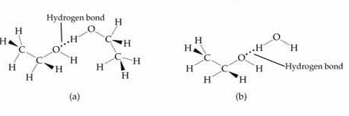
- When ethanol dissolves in water:
  - Hydrogen bonds between water molecules are broken
  - Hydrogen bonds between ethanol molecules are broken
  - Hydrogen bonds between water molecules and ethanol molecules are formed
- As the ethanol molecules are now surrounded by the water molecules the solution forming process can be represented by:

C₂H₅OH_{(l)} C₂H₅OH_{(aq)}

- The more polar the molecules of a molecular compound the more likely it is to dissolve in water.
- Look at Vit A and Vit C on page 197
- In general, the larger the non-polar fraction of the molecule, the less soluble it is in water.
- Non-polar substances (oil) are insoluble in water because water molecules form hydrogen bonds with each other in preference to the weak attractions with non-polar molecules.
- Like dissolves like
  - Polar solutes will readily dissolve in polar solutes
  - Non-polar solutes readily dissolve in non-polar solutes
- Paint as example: oil and water based paints

Polar Covalent Molecular compounds that ionise
- Some compounds have one or more covalent bonds that are so highly polarised they break when placed in water.
- They break as a result of the electrostatic forces of attraction between the solute molecules and the water molecules. Hydrogen chloride is an example.
- This attraction results in the hydrogen-chloride bond breaking- taking both bonding electrons stay with the chlorine atom.
- Therefore an H+ forms a covalent bond with a water molecule.
- Two ions are then formed
  - The H₃O+ ion and a Cl- ion
  - The H₃O+ is known as a hydronium ion
- This hydrolysis process is called ionisation.
- The HCL molecules have ionised in water.
- The chlorine and hydronium ions will be surrounded by water molecules – they are hydrated ions.
- The ionisation process can be represented by the equation
  - HCl(g) + H₂O(l) H₃O⁺(aq) + Cl⁻(aq)
- In summary
  - Polar covalent bonds within molecules are broken, producing hydrogen ions and anions.
  - Covalent bonds forms between each H+ and an H2O molecule, giving H3O+ ions. Ion-dipole attractions between the newly formed ions and the polar water molecules are formed.
- Other polar covalent molecular compounds that ionise in water include the common acids, nitric acid (HNO₃), sulphuric acid(H₂SO₄) and ethanoic acid (CH₃COOH)
Ionic Compounds
- Ionic solids contain positive and negative ions held in a 3-dimensional lattice by strong electrostatic forces.
- When ionic substances such as NaCl are placed in water:
  - The positive ends of the water molecule are attracted to the negatively charged chloride ions.
  - The negative ends of the water molecules are attracted to the positively charged sodium ions.
  - Because water molecules are in a state of constant random motion, they pull the sodium and chloride ions on the outer layer of the lattice into the surrounding solution.
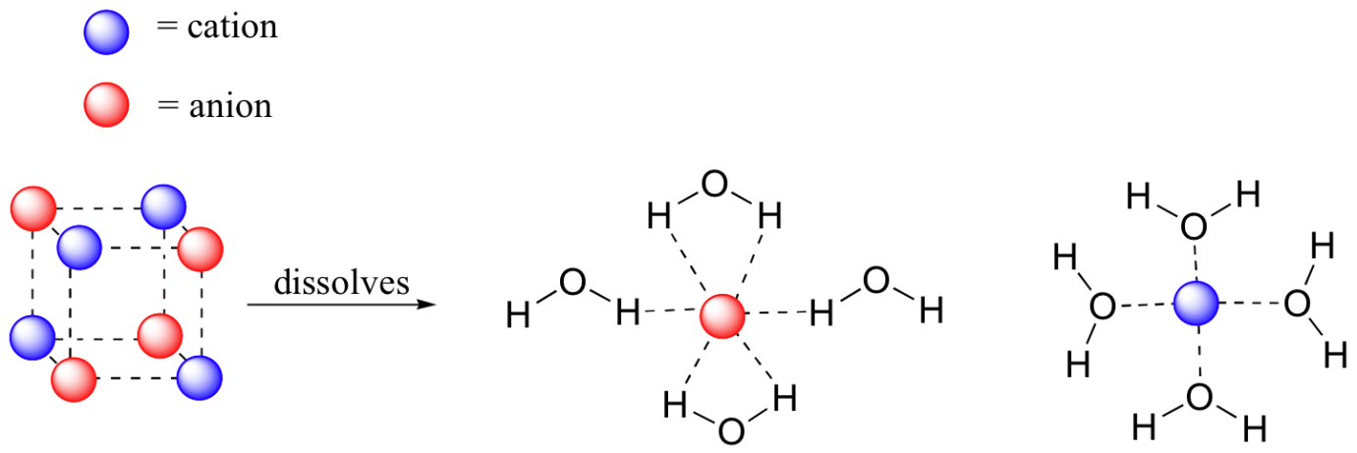
- When the sodium chloride has dissolved, the sodium and chlorine ions are surrounded by water molecules. The ions are said to be hydrated.
- The attraction between an ion and a polar molecule is described as an ion-dipole attraction.
- When an ionic compound is dissolved in water the positive and negative ions separate from one another. This process is called dissociation.
- The dissociation of sodium chloride can be represented by
H₂O
  - NaCl(s) Na+(aq) + Cl-(aq)
- When writing equations for dissociation they rules for balancing still apply
H₂O
K₂CO₃(s) 2K⁺(aq) + CO₃⁻²(aq)
In summary, when an ionic compound dissovles in water
- Ionic bonds within the solid are broken
- Hydrogen bonds form between water molecules are broken
- Ion-dipole attraction between the ions and the polar water molecules are formed.
- Not all ionic compounds are soluble in water
- For insoluble ionic substances the energy required to separate from the lattice is much greater than the energy produced when the ions become hydrated.
A solubility guide for common ionic compounds
Soluble Ionic Compounds
Most compounds of the following ions are soluble…. |  | Important exceptions
Nitrate (NO₃⁻) |  | None
Ethanoate(acetate) (CH3COO⁻) |  | None
Sodium, Potassium (Na⁺, K⁺) |  | None
Ammonium (NH₄⁺) |  | None
Chloride (Cl⁻) |  | AgCl, HgCl₂, PbCl₂ is slightly soluble
Bromide (Br⁻) |  | AgBr, HgBr₂, PbBr₂
Iodide (I⁻) |  | AgI, HGI₂, PBI₂
Sulfate (SO₃²⁻) |  | BaSO₄, PBSO₄, CaSO₄ is slightly soluble
Insoluble Ionic Compounds
Most compounds of the following ions are insoluble…. |  | Important exceptions
Sulfide (S²⁻) |  | Na₂S, K₂S, Li₂S, (NH₄)₂S
Carbonate (CO₃²⁻) |  | Na₂CO3, K₂CO₃, Li₂CO₃
Phosphate (PO₄³⁻⁾ |  | Na₃PO₄, K₃PO₄, Li₃PO₄
Hydroxide (OH⁻) |  | NaOH, KOH, BA(OH)₂, CA(OH)₂ is slightly soluble
- The most commonly used solubility rules are that all nitrates, ammonium compounds and compounds of group1 metals are soluble.
- Although substances are usually described as soluble and insoluble this is a generalisation.
- Insoluble tend to dissolve sparingly and soluble dissolve to varying extents.
- Plus the solubility of substances varies with temperature.
  - Most solids become more soluble with temp rises while gases tend to become less soluble as the temp rises.
Worked Examples
Predict the following
- Copper(II) nitrate (Cu(NO₃)₂)
- Glycerol (CH₂(OH)CH(OH)CH₂(OH))
- Octane (C₈H₁₈)
- Nitric acid (HNO₃)
- Barium carbonate (BaCO₃)

Chapter Questions: 6 – 12
Chapter Review 13 -20, 25 – 28, 30-34

