11.1 Measuring Solubility
- The solubility of a substance is the maximum amount of that substance that can be dissolved in a given quantity of solvent at a certain temperature.
- A solution in which no more solute can be dissolved at a certain temperature is described as a saturated solution.
- One way of measuring solubility is to determine the maximum mass of solute that can be dissolved in 100 grams of solvent at a given temperature.
Worked Example.
A maximum of 8 grams of solute can be dissolved in 25g of water at 22ºC. What is the solubility of this solute in water at 22ºC.

Solubility curves.
- The relationship between solubility and temperature can be represented by a solubility curve.
- Each point on the solubility curve represents a saturated solution.
  - No more solute can be dissolved at that temperature
- Any point below the curve represents an unsaturated solution.
  - An unsaturated solution contains less solute than is needed to make a solution saturated at that temperature.

Solubility Curve for some Common Salts
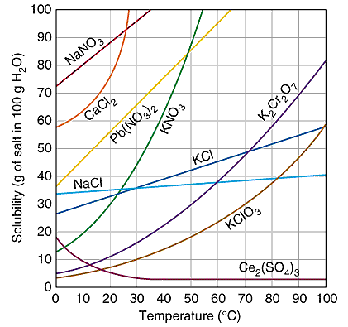
1. What is solubility of the following solutes?
a. Sodium chloride at 40ºC.
b. KClO₃ at 80 ºC.
c. Calcium chloride at 0 ºC.

2. A 20g sample of KNO₃ is added to 200g of water at 20ºC. Use the solubility curve to calculate how much more KNO₃ needs to be added to make the solution saturated at 20ºC?

Crystallisation
- Crystallisation will occur when the solute can longer stay dissolved in the solute due to a drop in temperature and comes out of the solution as crystals.
  - Crystallisation of honey at cold temperatures is one example.
Worked Example
What happens if a solution containing 50g of potassium nitrate in 100g of water is allowed to cool from 40ºC to 20ºC?

Supersaturation
- A supersaturated solution contains more dissolved solute than in a saturated solution.
- Any point above a solubility curve represents a supersaturated solution for that solute.
Temperature and Gas Solubility
- Gases become less soluble as the temperature increases.
The Changes in Solubility of some Common Gases in Water with Changing Temperature
Gas | Solubility (g of gas per kg of water)  0ºC 20ºC 60ºC
Oxygen | 0.069 | 0.043 | 0.023
Carbon dioxide | 3.4 | 1.7 | 0.58
Nitrogen | 0.029 | 0.019 | 0.011
Methane | 0.040 | 0.023 | 0.011
Ammonia | 987 | 529 | 168

Worked Example
Using the table above calculate the percentage of oxygen that would be lost from a lake where the temperature rises from 0ºC to 20ºC.

Pressure and Gas Solubility
- The solubility of gas increases with increasing pressure
- Carbon dioxide is forced into soft-drinks under high pressure.
- Can hear the gas escaping in the top of the bottle when opened and see the carbon dioxide escaping the liquid (bubbles) as the solubility of the CO₂ of the drink is lowered.
Textbook Questions 1 - 8

