16.5 Evidence for Electron Transfer.
A galvanic cell can be used to show that electrons are flowing from one substance to another.
When zinc metal is placed in a solution of copper(II) sulfate, the zinc is oxidised and a brown deposit of copper metal forms
Oxidation of Zinc:

Reduction of copper(II) ions:

Overall reaction:

Electrons flow from the zinc atoms to the copper(II) ions.
We can place the zinc metal and aqueous solution of copper(II) ions in separate beakers and measure the flow of electrons.

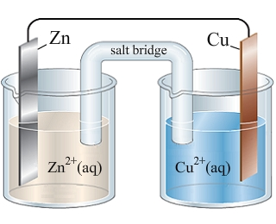

A galvanic cell is an energy converter that separates the oxidant from the reductant. Chemical energy is converted into electrical energy.
In the above cell, the galvanometer indicates that electrons are flowing from the zinc strip in beaker A to the copper strip in beaker B. This provides evidence that the oxidation and reduction reactions occur between zinc atoms and copper(II) ions even when separated.
The electrons flow through the zinc strip and connecting wires towards the copper strip.
The zinc strip is the source of the negatively charged electrons. The zinc strip is therefore assigned a negative charge. As the electrons are attracted to the copper strip, it is assigned a positive charge.
To maintain the balance of positive and negative charge in each beaker, ions flow from the salt bridge into each beaker. K⁺ ions flow into and replace Cu²⁺ ions and NO₃⁻ ions flow into the beaker containing the ZnCl₂ solution. Their negative charge balances the positive charge on the Zn⁺ ions that are being produced at the zinc electrode.
Galvanic Cells
- All galvanic cells are composed of two half cells.
- Oxidation occurs in one half and reduction in the other.
- A half cell must contain an electrode and an electrolyte.
An electrode is an electrical conductor and by definition:
- The electrode at which oxidation takes place is called the anode.
- The electrode at which reduction takes place is called the cathode.

In the above example name the electrodes and which was the anode and which was the cathode and name the electrolyte in each beaker.

