16.6 The Electrochemical Series
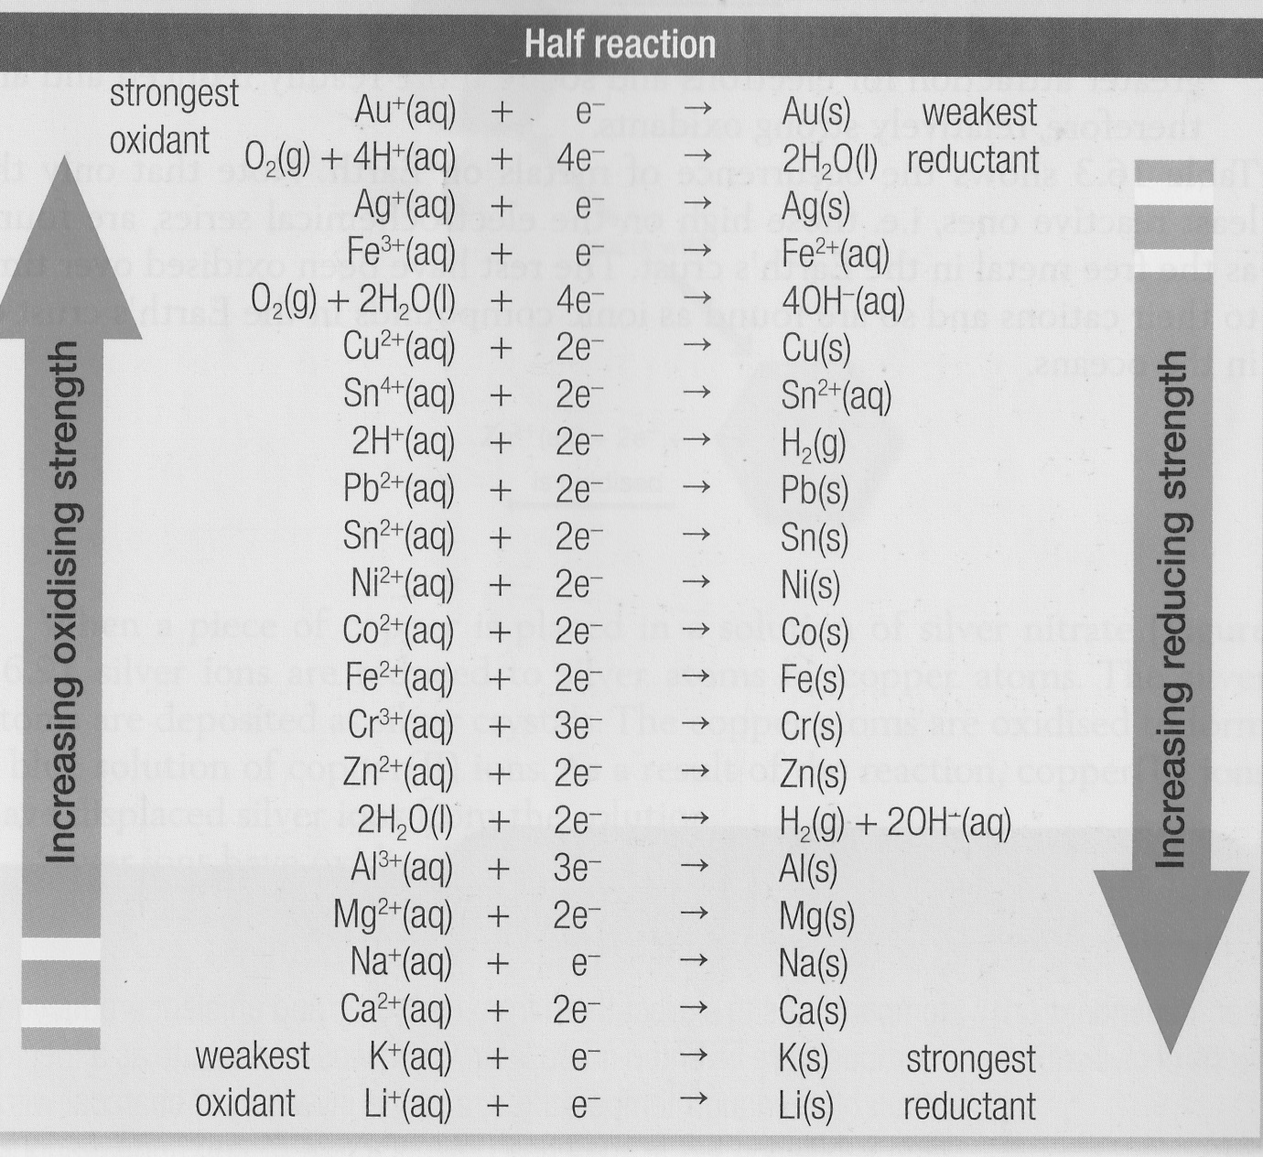

The electrochemical series lists half equations in order of their tendency to occur as reduction reactions.
As you go down the electrochemical series, the:
- Metals (right-hand side) become increasingly easy to oxidise and therefore more reactive. Metals lower in the series lose electrons more readily and so are stronger reductants.
- Metal cations (left-hand side) become increasingly hard to reduce and therefore less reactive. Cations higher in the series have a greater attraction for the electrons and so are more readily reduced and are relatively strong oxidants.

Predicting Redox Reactions.
The electrochemical series is useful for predicting redox reactions.
More reactive metals tend to be found on the lower right. A more reactive metal will be oxidised by and donate its electrons to the cation of a less reactive metal. The cation receives the electrons and is reduced.
A spontaneous redox reaction can be expected to occur when a relatively strong oxidant is mixed with a relatively strong reactant.

The oxidant is reduced and the half equation occurs in the forward direction (as shown in the electrochemical series)
The reductant is oxidised and its half equation is the reverse of that on the series chart.

For example we can predict that zinc metal will react with Cu2+ ions because zinc is more reactive than copper. The half equations can be obtained from the series table.
Oxidation half equation:

Reduction half equation:

Overall equation:

Fill out the following information for silver and copper.

Oxidation half equation:

Reduction half equation:

Overall equation:

