  - The foundations of chemistry.
By about 1900, experimental evidence indicated that atoms contained positively charged particles and much smaller negatively charged particles.
Cathode Rays
In 1958 Julius Plucker conducted experiments using a cathode ray tube.
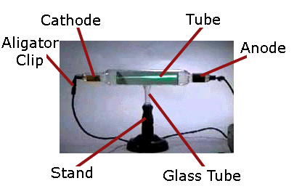

When high voltage was applied the tubes glowed with a coloured light. Plucker suggested that the florescence was caused by invisible rays coming from the cathode and called them cathode rays. When an electric field was applied at right angles, the florescence moved away from the negative pole of the electric field.

Suggest a reason for this occurrence:

In the 1890’s, Joseph Thomson repeated Plucker’s experiments with different metals and gases and found, in every case, the results were the same. Thomson proposed that:
- The observed rays were a stream of particles coming from the negatively charged cathode
- Because they came from negatively charged cathode and were repelled by the negative charge, the particles must be negatively charged themselves.
- These negatively charged particles must be present in all elements. They must be ‘subatomic particles’ present in all matter.
An Early Atomic Model
‘A scientific model is a description that scientists use to represent the important features of what they are trying to describe. They are able to test the consistency of their observations against various predictions of the model.’
As atoms are too small to see, chemists use models to represent them. These models change with time as we learn more about the paricles that make up atoms.
1897 – Thomson took the latest experimental evidence and proposed an atomic model.
He imagined an atom to consist of a sphere of positive matter in which negative particles were imbedded randomly like plums in a pudding. This became known as Thomson’s ‘plum pudding’ model.

Thomson’s model replace that of Dalton’s who had propsed that atoms were a very small, solid ball of matter.
By 1900, it was accepted that atoms contained positively charged particles, called, protons, and much smaller negatively charged particles, called electrons.

Text Questions 1 and 2

