2.2 The Nuclear Atom.
1911 – Ernest Rutherford proposed a new model of the atom. His model is based on the experimental evidence he collected from the following experiment.
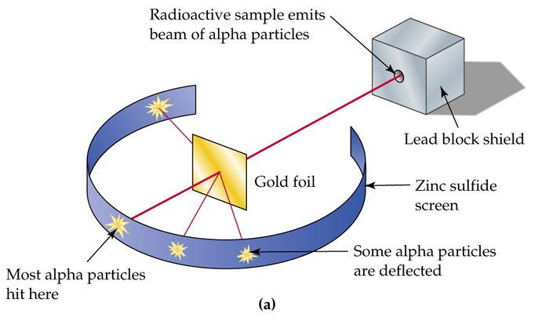
Rutherford fired alpha particles at a thin sheet of gold foil. A screen behind the gold produced bursts of light when the alpha particles came into contact with it. Rutherford found that most of particles passed straight through the gold as if it wasn’t there. One in 8000 particles were deflected away from the normal line and occasionally one would almost bounce straight back.
Rutherford’s model proposed the following:
- Most of the mass of an atom and all the positive charge, must be located in a tiny central region, he called the nucleus.
- Most of the volume of an atom is empty space, occupied only by electrons
- The electrons move in circular orbits around the nucleus
- The force of attraction between the positive nucleus and the negative electrons is electrostatic.

1914 – Rutherford concluded that the nucleus was of positive charge and called this a proton.
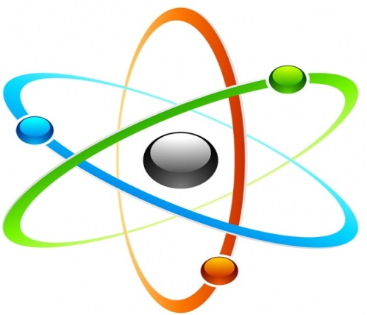Rutherford’s Nuclear Atom

Discovery of the Neutron.
1932 – James Chadwick identifies the particle that was uncharged and had a mass a little greater than a proton and named these neutrons. He reasoned that the nucleus of an atom must contain neutrons as well as protons. Therefore a helium atom, which is four times heavier than hydrogen has two protons and two electrons.
Subatomic particles
Subatomic Particle | Mass relative to proton | Charge

Chadwick could also explain a problem faced by Rutherford when he identified a substance that was chemically similar to thorium and called it thorium-X. Fredrick Soddy suggested that particular varieties of elements existed and called these isotopes.
Chadwick knew now that the isotope of particular elements have the same number of protons and electrons, but differ in the number of neutrons found in the atom.
In nature, different elements have different numbers of isotopes. Gold has only one isotope, lead has four while mercury has seven.

Characteristics of Atoms.
Scientists were now able to summarise the key characteristics of atoms.
- All atoms are electrically neutral. The number of protons is exactly equal to the number of electrons.
- All atoms of the same element contain the same number of protons and so the same number of electrons.
- The number of protons in the nucleus is called the atomic number and given the symbol Z.
- The mass number of an atom gives an indication of the mass of that atom relative to other atoms. Since the protons and neutrons make up almost all the mass, the mass number is defined as the total number of protons and neutrons and is given the symbol A.
- All atoms of an element have the same number of protons, but the number of neutrons can vary. Atoms of the same element with different numbers of neutrons are called isotopes of that element. Isotopes have the same atomic number but a different mass number.
- An isotope can be represented by the symbol of the atom together with the atomic and mass numbers
${}_{Z}^{A}X$
Symbol of element
Atomic number
Mass number
So therefore an isotope of uranium, which has 92 protons and 143 neutrons, is written as:
Mass Number:
Symbol:
Atomic Number:

Ions.
When an atom loses or gains an electron, it produces a charged particles known as an ion.
An ion with fewer electrons than protons is a positive ion and an ion with more electrons than protons is a negative ion.
Worked Example 1.
Sodium has an atomic number of 11 and a mass number of 23 therefore:
____ protons _____ neutrons _____ electrons
Represented as:

If we were to remove an electron we would be left with an ion that had:
____ protons _____ neutrons _____ electrons
Represented as:

Worked Example 2.
Oxygen has an atomic number of 8 and one isotope has a mass number of 16.
We represent this oxygen atom as

If we were to add two electrons we would represent this ion as:

Text Questions: 5 – 9.
Workbook: 3

