2.3 Arranging electrons around a nucleus.
- Rutherford’s model proposed that electrons move in circular orbits around the nucleus with electrostatic force of attraction between positive and negative.
- It did not explain why, according to the laws of physics, did not emit observable (light) electromagnetic radiation and as this radiation is emitted, electrons should lose energy and spiral into the nucleus.
- The model did not explain why when an element is heated only light of specific energies are released. (see figure 2.14 page 24)
1913 – Niels Bohr suggests that the laws of physics that are used to explain motion in large objects doesn’t apply to very small objects such as electrons. He proposed that electrons in atoms:
- Circled the nucleus without losing energy
- Could move only in certain fixed orbits of particular energy.
The orbit in which an electron moved depended on the energy of the electron: electrons with low energy were closed to the nucleus while high-energy electrons were in outer orbits.
The Bohr Model.

- Heating an element can cause an electron to absorb energy and jump to a higher energy state.
- The electron returns to the lower energy state, releasing a fixed amount of energy.
- Electrons can return in a number of ways, each possible way produces light of a particular colour in the emission spectrum.

Bohr’s model was based on the hydrogen atom and scientists quickly extended his ideas to other elements and the idea of successive ionisation energies.
- Sodium has 11 electrons and it is possible to measure the ionisation energies as each of these electrons are removed.
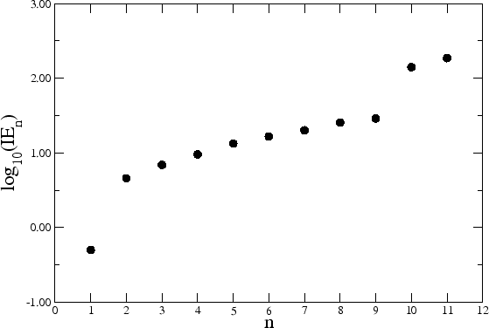

- The graph shows that the first electron is easily removed.
- The next eight are removed less easily and each required a similar energy for removal.
- The last two take more energy still to remove them.
This lead to the conclusion that electrons were grouped in different energy levels, which were called shells.
Electron in the same shell:
- Are about the same distance from the nucleus
- Have about the same energy.
Greatest amount of energy required

Least amount of energy required
The different shells can hold different numbers of electrons. The maximum held in each shell is summarised below.
Shell Number | Maximum number of electrons
1
2
3
4
n | 2n² (where n is the shell number)

- The lowest energy shell closest to the nucleus, known as the first shell, can hold two electrons.
- The second can hold eight.
- The third eighteen.
- And the nth shell can hold 2n² electrons.
The way the electrons are arranged around the nucleus is known as the electronic configuration. Generally in a stable atom inner shells are occupied before outer shells. The electronic configuration is written as number in first shell, number in second shell, number in third shell, etc (eg 2,8,18)
Worked Example 1.
Lithium has _______ electrons.
Lithium’s electronic configuration is therefore:

A simple diagram is used to show the arrangement of electrons around the nucleus. Only the shells occupied are shown. (hydrogen has just as many shells as all other elements, but tends to only use one and therefore only one is shown)
After the second shell, the electrons fill in stages. The outmost shell can never contain more than eight electrons, regardless of the maximum, until there are at least two electrons in the following shell.
The electrons in the outermost shell are called the valence electrons. The valence electrons are involved in chemical reactions. (They take the least amount of energy to remove)
Worked Example 2
Write and draw the electronic configuration for lithium, sodium and potassium and then state the number of valence electrons for each.

Text Questions: 10 - 13.

