20.1 Nitrogen
Properties:
- A colourless and odourless gas.
- Insoluble in water.
- Generally unreactive.
Uses:
- Plants need a continual supply because nitrogen atoms are present in key compounds in all living things.
- Nitrogen-based fertilisers are used to complement bacterial nitrogen fixation.
- Used when an unreactive oxygen-free environment is required such as welding, some extinguishers.
- The low boiling point of liquid nitrogen is useful for the storage of sperm, eggs and embryos.
Commercial Production:
- Nitrogen is produced by the fractional distillation of liquid air.
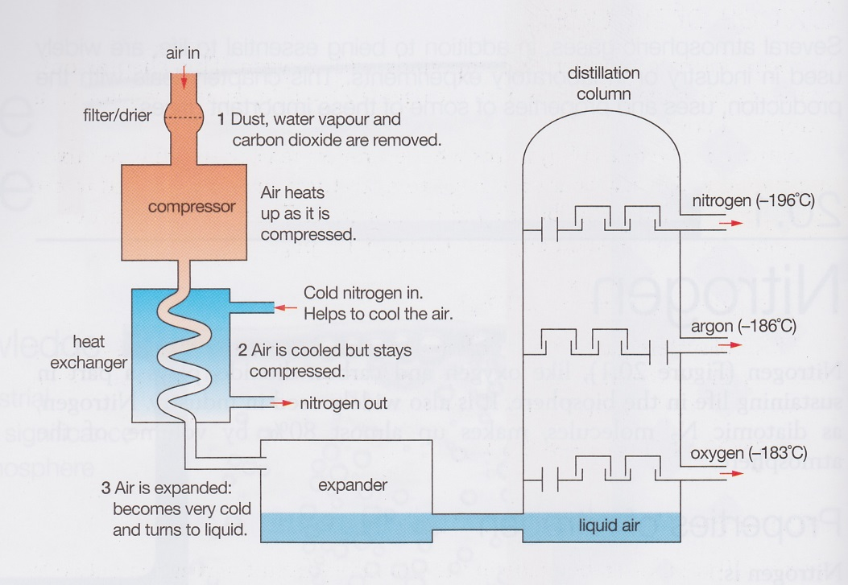

Oxides of Nitrogen

Nitrogen forms a number of compounds with nitrogen such as nitrogen(II) oxide and nitrogen(IV) oxide (nitrogen dioxide).

Nitrogen(II) oxide (NO) forms at high temperatures when nitrogen and oxygen mix. This occurs during lightning and meteor trails. It can also form in volcanoes and combustion engines.
Nitrogen(II) oxide is difficult to isolate because it reacts readily with oxygen, at low temperatures, to form poisonous nitrogen(IV) oxide (NO₂).

Laboratory Preparation of Nitrogen(II) oxide and Nitrogen(IV) oxide.
Nitrogen(II) oxide can be produced from the reaction of 50% nitric acid with copper and collected by the displacement of water.

Nitrogen(IV) oxide can be produced from the reaction between concentrated nitric acid and copper. Since the gas is soluble in water but denser than air, it is collected by the upward displacement of air.

