21.1 Behaviour of Gases
The Properties of the three states of Matter.
Gases | Liquids | Solids
Low density | High density | High density
Spread to fill the space available | Fixed volume; adopt shape of container | Fixed volume; generally rigid shape
Mix together rapidly | Mix slowly unless stirred | Don not mix unless finely divided

Observations can be used to develop a particle model of gas behaviour.
- The low density of gas, relative to liquid and solids, suggests that the particles of gases are space more widely spaced.
- Gases spread to fill the space available suggests that the particles move independently of each other.
- The wide spacing together with their movement explains why gases mix rapidly.
21.2 Kinetic Molecular Theory
The model used by scientists to explain gas behaviour is known as the kinetic molecular theory.
According to this model:
- Gases are composed of small particles (atoms or molecules). The total volume of the particles in the sample is very much smaller than the volume occupied by the gas. Most of the volume taken up by the gas is empty space.
- These particles move rapidly in a random, straight line motion. Particles will collide with each other and with walls of the container.
- The bonding forces between particles are extremely weak. It is assumed that particles move around independently.
- Collisions between particles are elastic (energy is conserved). Kinetic energy (movement) can be transferred from one particle to another, but the total kinetic energy will remain constant.
- The average kinetic energy of the particles increases as the temperature of the gas is increased.

Relationship between molecular kinetic energy and temperature.
The average kinetic energy of gas particles is proportional to the temperature of the gas samples remembering that at any given temperature:
- The average kinetic energy of the gas is not dependant on the particular gas
- Within each gas sample there will be some particles of very low kinetic energy and some of high energy. The temperature merely reflects the average kinetic energy of particles in a given sample.
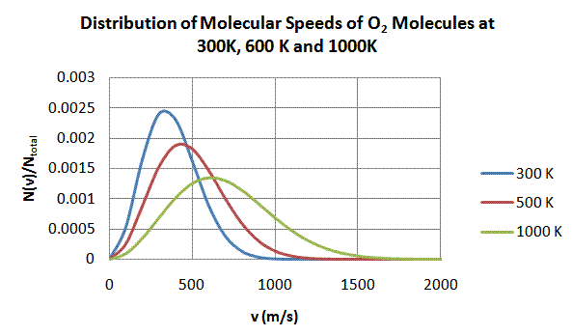
The distribution of the kinetic energy of particles in a gas at a given temperature can be illustrated by the graph above. It shows the relative number of oxygen molecules with a given kinetic energy at three different temperatures.
From the graph:
- Only a small proportion of molecules have a very low or very high kinetic energy.
- At all three temperatures, there are some molecules with very low kinetic energy.
- The proportion of molecules with high kinetic energy increases with temperature.
- The average kinetic energy of the sample increases with temperature.
- The area under each graph represents the total number of oxygen molecules which are all equal.
As the average molecular kinetic energy of particles in different gases is the same at a given temperature we can say that the lighter the gas atoms or molecules in a sample, the greater their average velocity.
Diffusion is the term used to describe how each gas in a mixture spreads itself evenly to fill the total volume available. The rate of diffusion depends on the average velocity of their particles. So gases of relatively lower molecular mass will diffuse more rapidly than gases of higher molecular mass and as the average kinetic energy is greater at higher temperatures, diffusion will occur more rapidly at higher temperatures than lower.
A very useful property of gases is that it can be compressed in a container. The more the gas is compressed, the greater the number of collisions the gas particles will with each other and the wall of the container. These collisions produce a force on the walls of the container (such as a car tyre). This force on the wall area is measured as pressure.
The pressure of a fixed amount of gas is independent of the actual gas being considered. So in a gaseous mixture like air, nitrogen molecules collide with the walls of a container and exert a pressure. The oxygen molecules exert a pressure, the carbon dioxide molecules exert a pressure and so on for each gas in the mixture. The measured air pressure is the sum of these individual gas pressures.
These individual gas pressures are known as partial pressures. The nitrogen in air exerts the same amount of pressure as if it was the only one in the container, the same for oxygen and any other gas present.
- The total pressure of a mixture of gases is the sum of the partial pressures of each of the gases in the mixture.
If oxygen at 20ºC exerts a partial pressure of 20 kPa and nitrogen at 20ºC exerts a partial pressure of 85 kPa, what is the pressure of a mixture of the two at 20ºC?

The pressure will only increase in a container if one or more of the following occurs:
- the amount of gas is increased
- the temperature of the gas is increased
- the volume of the container is decreased.

