3.1 Why is the periodic table important?
The ideas from chapter 1 and the understandings from chapter 2 has made the periodic table the most useful reference available to scientists.
It minimise the need to memorise isolated facts and provides a framework to organise knowledge. Knowing the properties of elements and trends within the table, chemists can comprehend what would be an overwhelming collection of disorganised experimental data. With the table chemists can extrapolate from known facts to the unknown.
3.2 Why are the element properties periodic?
Mendeleev proposed his periodic law: The properties of elements vary periodically with their atomic weight.
The number of protons, or atomic number, is now known to be the fundamental difference between atoms of different elements, rather than the atomic weight. As a result the modern table has elements arranged in order of increasing atomic number.
Mendeleev looked at two groups of elements that he recognised as being similar.
The first group is the alkali metals. The elements in this group are all relatively soft metals and are highly reactive with water and oxygen.
Consider their electronic configurations:
Lithium: 1s² 2s¹
Sodium: 1s² 2s² 2p⁶ 3s¹
Potassium: 1s² 2s² 2p⁶ 3s² 3p⁶ 4s¹
Rubidium: 1s² 2s² 2p⁶ 3s² 3p⁶ 4s² 4p⁶ 5s¹
Caesium: 1s² 2s² 2p⁶ 3s² 3p⁶ 3d¹⁰ 4s² 4p⁶ 4d¹⁰ 5s² 5p⁶ 6s¹
What is similar about their electronic configurations?

The second group he looked at was the halogens. They are all coloured and highly reactive.
There electronic configurations are:
Fluorine:
Chlorine:
Bromine:
Iodine:
What is similar about their electronic configurations?

The electrons in the outer shell of an atom are known as the ________________________.
The arrangement of electrons in atoms is responsible for the periodicity of element properties.
The recurrence of the same outer-shell electronic configuration is responsible for elements in a group having the similar properties. These are the electrons that are generally involved in forming chemical bonds.
Mendeleev’s periodic law can be restated in modern terms as:
Variations of the chemical properties of elements across a period and similarities down a group are all associated with the electronic configurations of their atoms.

Many versions of the periodic table have been designed to emphise the relationship between elements. The form of the table over the page is in common use today. Page 52 of your text shows two other versions of the periodic table.

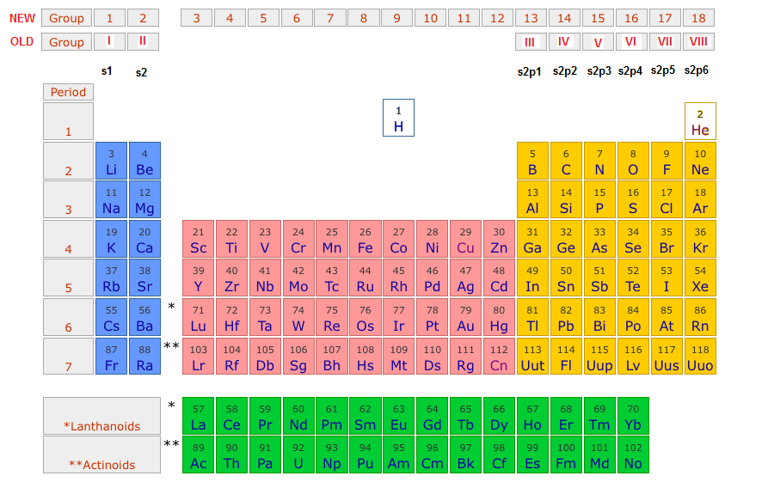

This table has the following features:
- Vertical columns are called groups. Groups contain elements with similar outer-shell electronic configuration. For example the alkali metals in group 1 all have a half-filled s-orbital (s¹) in their outer shell.
- Groups are numbered 1 – 18.
- Horizontal rows are called periods. Periods are numbered 1 – 7 and each contains elements with electrons in the same outer shell. The number of the period is the same as the number of the outer shell. For example magnesium and silicon both have a third outer shell and both are in period 3.
Blocks of Elements.
The periodic table can be regarded as having four main blocks of elements with the elements in each block all filling the same type of subshell:
- The s-block contains the elements in group 1 (alkali metals) and group 2 (alkaline earth metals). These elements have half-filled or filled s-subshells or s¹ or s² as the highest energy subshell.
- The p-block contains elements in groups 13 – 18. A p-subshell is the highest-energy subshell of elements in this section. The elements have outer-shell configurations from s² p¹ to s² p⁶.
- Elements in the s- and p-blocks are often referred to as main group elements.
Helium is usually placed in group 18 even though it has a configuration of 1s² as its atoms are unreactive like the other atoms in group 18.
Hydrogen has an s¹ outer shell (group 1) but behave quite differently from group 1 metals. It is usually placed on its own rather in group 1.
- The d-block, contains the elements known as transition metals and is located between the s- and p-blocks. It contains elements in which the five orbitals, with a max of 10 electrons, of a d-subshell are progressively filled. Transition metals have an outer-shell configuration from d¹s² to d¹⁰s².
- The f-block contains the lanthanides and actinides. The lanthanides are a set of 14 elements with atomic numbers form 58 – 71. The actinides have atomic numbers 90 – 103. The seven orbitals (max of 14 electrons), in the 4f-subshell are progressively being filled in the lanthanides and the 5f-orbitals in the actinides.
Although not in a separate block, the elements 93 onwards are worth a mention. Uranium (92) is the last element to be found naturally in Earth. The transuranic (higher atomic number than uranium) elements have been created in laboratories.

Text Questions 1 – 7
Workbook: 5

