5.2 Properties and Structure
The physical properties and inferred structural features of metals.
Property | What this tells us about structure
Metals conduct electricity in the solid state | Metals have charged particles that are free to move
Metals are malleable and ductile | The forces between the particles must be able to adjust when the particles are moved
Metals generally have high densities | The particles are closely packed in a metal
Metals tend to have boiling points | The forces between the particles must be strong
Metals are lustrous or reflective | Metals can reflect light

From the table we can deduce that model must be one in which:
- Some of the particles are charged and free to move
- There are strong forces of attraction between particles throughout the metal structure.
The Metallic Bonding Model
So what particles are free to move and how are they arranged?
The only particles that are small enough to move through a solid lattice are electrons. If a metal atom loses one or more electrons from its outer shell it forms a positive ion or cation.
Cation example:

Lattice Structure:

Chemists believe that in a solid sample of metal:
- Positive ions are arranged in a closely packed structure. This is described as a regular, three-dimensional lattice of positive ions. The ions occupy fixed positions in the lattice.
- The much smaller negatively charged electrons form the outer shell of the metal atoms are free to move throughout the lattice. These electrons are called delocalised electrons because they belong to the lattice as a whole. The delocalised electrons come from the outer or valence shell. Electrons that are not free to move are said to be localised. Electrons in the inner shells are localised.
- The ions are held in the lattice by the electrostatic force of attraction that extends throughout the lattice and is called metallic bonding.
Diagram of the metallic bonding model

The diagrams below show how the metallic bonding model is consistant with the relatively high boiling temperatures, electrical conductivity and malleability and ductility of metals.
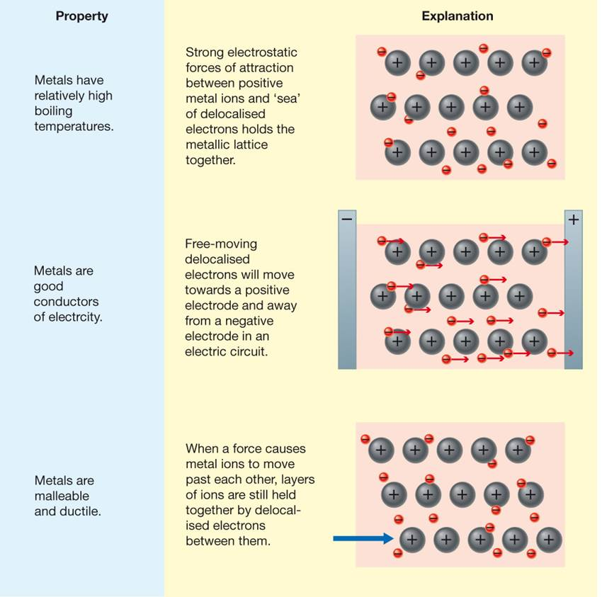
Metals are good conductors of heat. Heating a metal gives the positive ions and electrons more energy and they vibrate more rapidly. The electrons being free to move transmit this energy rapidly throughout the lattice.
Metals are lustrous because of the presence of free electrons in the lattice; they reflect light and appear shiny.
Metals are generally dense. The ions in the lattice are closely packed together. The density depends on the mass of the ions, their radius and the way they are packed in the lattice.

Metals tend to react by losing electrons. The reactivity of a metal depends on the ease with which electrons can be removed. Potassium has a lower ionisation energy than sodium, less energy is required to remove an electron from potassium than sodium and hence potassium is more reactive.
Limitations of the metallic bonding model
There are some properties that cannot be explained as simply using the model:
- The range of melting temperatures and densities of different metals
- The differences in electrical conductivity between metals
- The magnetic nature of metals.

Text Questions: 5 & 6
Extension: 1 & 2

