5.3 Modifying Metals
Few metals are used in their pure form. Aluminium (does not corrode, conducts heat well and light) and copper (excellent electrical conductor) and examples of two metals that are used in their pure form.
Most metals need to be modified to produce the correct properties that we require for particular uses. Pure iron is not usually hard enough for many of its desired uses. So iron can be converted to steel by mixing up to 2% carbon. Other kinds of steel can be produced by adding other metals to the carbon / iron mixture.
The properties of a metal can be significantly altered by adding small amounts of another substance, usually a metal or carbon. The substances are melted together, mixed and then cooled. The resultant solid is called an alloy.
Making Alloys
There are two main types of alloys: substitutional and interstitial alloys
Substitutional alloys are made from elements that have fairly similar properties and atoms of similar sizes. Australian silver coins are made from an alloy of 75% copper and 25% nickel. The nickel atoms take the place of some of the copper atoms in the lattice. Both the nickel and copper ions are attracted to the sea of electrons, so the lattice is still strongly bonded. As there is a slight difference between the size of the atoms there is a restriction when the layers within the lattice move. This makes the alloy harder and less malleable than pure copper.

In interstitial alloys, a small proportion of an element with significantly smaller atoms is added to the metal. Adding carbon to iron is an example to increase irons strength to produce steel. The smaller carbon atoms fit randomly inbetween the hollows of the metal ions. This makes the layers harder to slide past each other, again making it harder and less malleable.

Table 5.3 (page 86) shows features of some common alloys.
In general, alloys are harder and less malleable than the metals they are made from. They are also poorer electrical conductors than the pure metals.
Work Hardening and Heat Treatment
The way a metal has been prepared will also affect how it behaves. Many metals are prepared in the liquid state and then cooled. The rate at which a metal is cooled has a significant effect on the properties of the cooled solid.
The model that we use to describe the structure of metals refers to the arrangement of particles within a single metal crystal. A crystal is a region in a solid in which the particles are arranged in a regular way. A sample of solid metal consists of a large number of small crystals. Each individual crystal is a lattice of ions surrounded by a sea of delocalised electrons but the arrangement of individual crystals with respect to one another, is random. At the point where one crystal meets another, the regular lattice is disrupted.
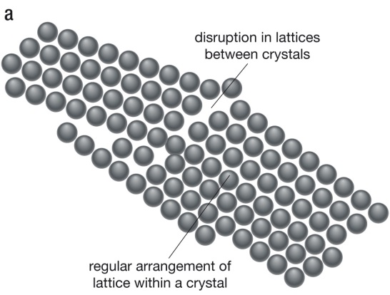
The way the metal behaves (malleability and brittleness) will depend on some extend to the size of the crystals and the how they are arranged.
- Generally the smaller the crystal, the harder the metal, as there will be less free movement of layers of ions over each other.
- However smaller crystal size also means more areas of disruptions between them and generally an increase in brittleness.
The crystal structure of metals can be altered. Two ways include work hardening and heat treatment.
Work Hardening
Hammering or working cold metals causes a rearrangement of the crystal grains and a hardening of the metal.
Heat Treatment
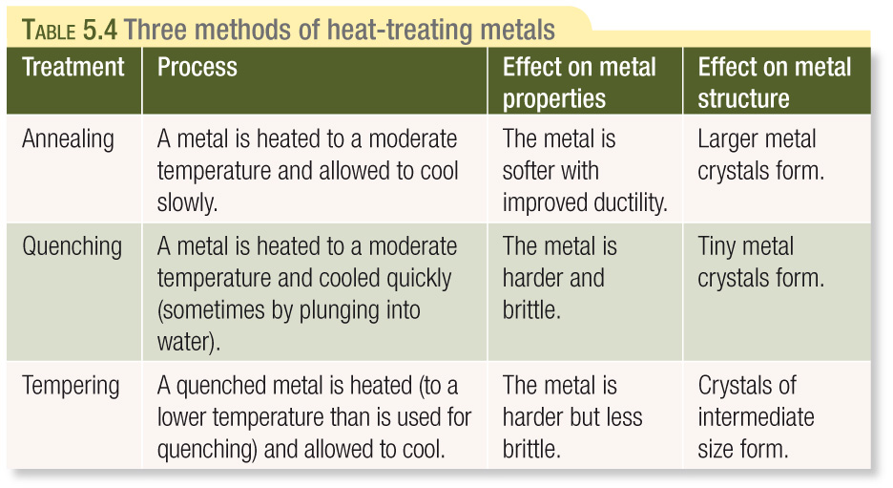

Key Terms
Alloy ductile quenching
Annealing interstitial alloy substitutional alloy
Brittle ion tempering
Cation lattice
Delocalised electrons malleable

Text Questions: 7 & 8
Chapter Review: 9 - 26

