6.1 Properties of Ionic Compounds
Ionic compounds:
- Have high melting and boiling temperatures
- Are brittle
- Are hard
- Do not conduct electricity in the solid state
- Will conduct electricity if they are melted or dissolved in water.
To discover what these properties revel about the particles in ionic compounds we will use sodium chloride as the example.
The physical properties and inferred structural features of sodium chloride
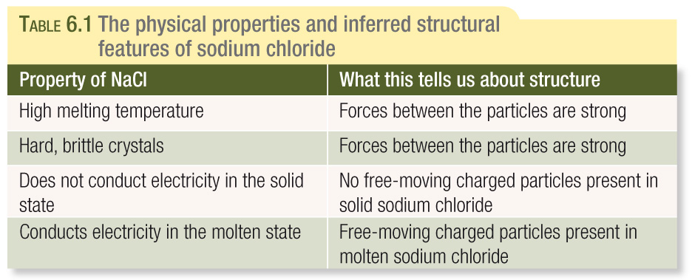
Ionic bonding occurs between a metal and a non-metal.
Chemists believe the following steps occur when metallic and non-metallic atoms form ionic compounds:
- Metal atoms lose electrons to non-metallic atoms and so become positively charged ions.
- Non-metal atoms gain electrons from metal atoms and so become negatively charged non-metal ions.
- Large numbers of positive and negative ions formed in this way then combine to form a three-dimension lattice.
- The three-dimensional lattice is held together strongly by electrostatic forces of attraction between the positive and negative ions. The electrostatic force of attraction holding the ions together is called ionic bonding.
In the case of sodium chloride, to maximise the forces of attraction each sodium ion is surrounded by six chloride ions and each chloride ion is surrounded by six sodium ions.
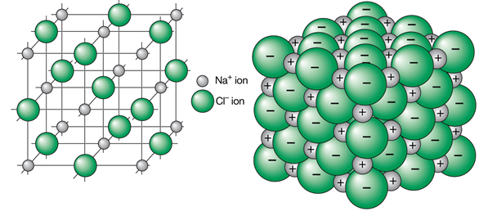
High Melting Temperature
To melt an ionic solid, energy must be provided to allow the ions to break free and move. Sodium chloride melts at 801ºC therefore the attraction between the positive sodium ions and the negative chloride ions is strong. A large amount of energy is required to overcome this electrostatic force.
Hardness and Brittleness
There are strong electrostatic forces of attraction (ionic bonding) between ions so a strong force is required to disrupt the crystal lattice, hence a sodium crystal cannot be scratched very easily. But if a strong force such as a hammer blow is applied the crystal shatters and is said to be brittle. This is because the layers of ions will move relative to each other due to the blow. During this movement ions of like charge will become adjacent to each other and repel away causing the crystal to shatter.
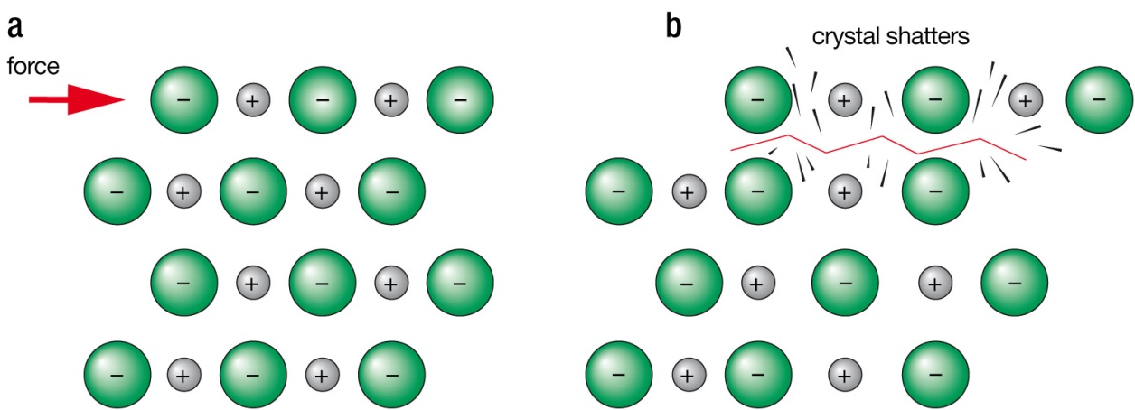

Electrical Conductivity
In the solid form, ions in sodium chloride are held in the crystal lattice and are not free to move therefore solid sodium chloride does not conduct electricity.
When the solid melts or is dissolved in water, the ions separate and are free to move.
Reaction of metals with non-metals
Why do metal atoms form positive ions and non-metal negative ions?
Remember:
- Metallic elements have low ionisation energies and low electronegativies.
- Non-metallic elements have high ionisation energies and high electronegativies.
Therefore
- Metal atoms lose electrons relatively easily.
- Non-metal atoms gain electrons relatively easily.
So when metal atoms react with non-metal atoms, the metal atoms lose electrons to the non-metal atoms. When this happens, both atoms will often achieve the electronic configuration of the nearest noble gas. A noble gas electronic configuration is particularly stable which accounts for the reactivity of the group 18 elements.
Example Sodium reacts with Chlorine

Atom | Electronic configuration of atom | Ion formed | Electronic configuration of ion | Noble gas with same electronic configuration
Magnesium (Mg)
Potassium (K)
Oxygen (O)
Sulfur (S)

In general the following will occur in a reaction between a metal and non-metal to form an ionic compound:
- Metal atoms lose electrons to form positively charged ions (cations)
- Non-metal atoms gain electrons to form negatively charged ions (anions)
- The ions formed by the atoms of a main group element will generally have the same electronic configuration as the noble gas nearest to that element on the periodic table.

Text Questions: 1 – 5
Workbook: 16

