7.1 Three Different Forms of Carbon.
Charcoal, diamond and graphite all consist only of the non-metal element carbon. They are all different physical forms, allotropes, of carbon and their physical properties are very different.
The physical properties of a substance reflect the nature of the particles present and the strength of the bonding between particles. Substances with very high melting points generally have strong bonds. When these substances melt, the bonds between the particles break down and the particles can move.
Diamond consists of carbon atoms bonded very strongly to other carbon atoms in a three-dimensional lattice, therefore diamond is very hard and crystalline and has a very high melting temperature.
Graphite is very hard in two dimensions but quite slippery in the other direction. Within each layer, the carbon atoms are very strongly bonded to three other carbon atoms but between the layers there is very weak bonding.
The structure of charcoal has been the subject of research and scientists think that they might be made up of fragments of buckyballs, which are particles shaped roughly like a soccer ball and made up of groups of 60 carbon atoms.
Compounds of Carbon
Carbon readily forms many compounds with other non-metals and many of these compounds consist of very small molecules which are gases at room temperature. Solid carbon dioxide (dry ice) has the ability to sublime, that is, go from a solid to a gas without passing through the liquid phase.
Carbon dioxide consists of a carbon atom bonded to two oxygen atoms. The carbon dioxide molecule is small with very strong bonds holding the carbon and oxygen atoms together, but with very, very weak forces between the molecules. As a result the molecules are easy to separate and so dry ice sublimes.
It is important to remember that in the gaseous state, carbon dioxide still retains its molecular structure of one carbon atom bonded to two oxygen atoms.

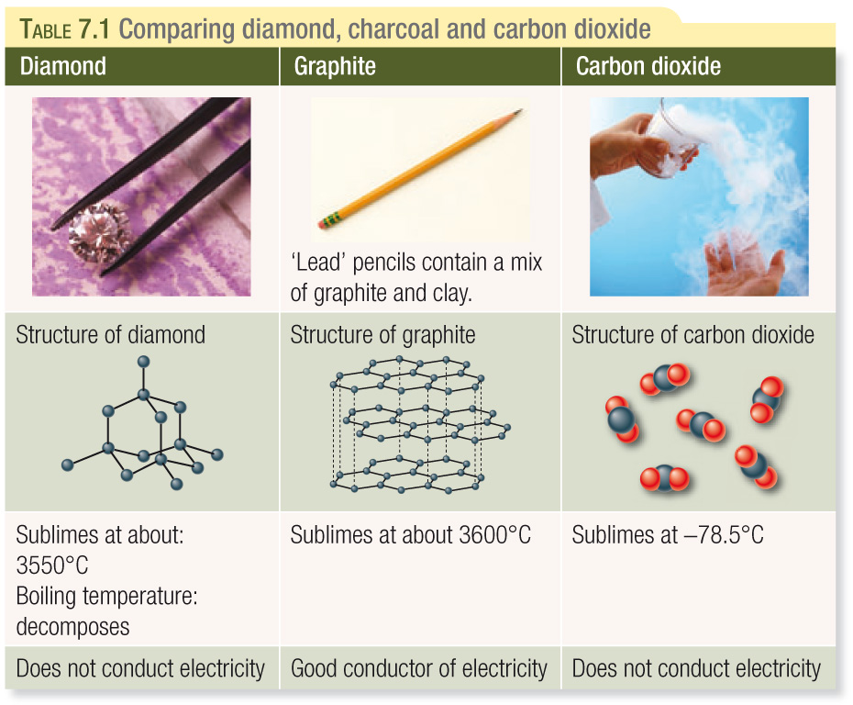
The type of bonding between carbon atoms in diamonds and graphite and carbon with oxygen in carbon dioxide is all the same type. It involves the sharing of electrons and is called covalent bonding. Atoms in a covalent substance are atoms of non-metallic elements.
Covalently bonded substances can consist of small covalent molecules or as covalent lattices.
Covalent Molecules: consist of two or more atoms of non-metallic elements. Carbon dioxide consists of exactly one carbon and two oxygen atoms. Sugar molecules consist of exactly 12 carbon, 22 hydrogen and 11 oxygen atoms (C₁₂H₂₂O₁₁).
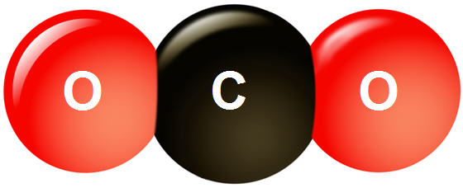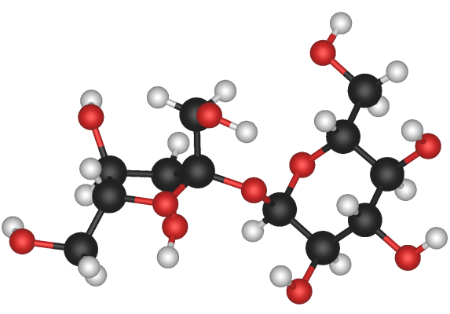

Covalently bonded substances such as diamond and graphite exist as covalent lattices, in which a huge number of atoms are joined together.
Most substances that exist as covalent molecules are liquids or gases at room temperatures. There are only weak forces of attraction between the molecules and hence the melting and boiling temperatures of these substances tend to be low.
All substances that exist as covalent lattices are solids at room temperature because all the atoms in the lattice are held to one another by strong covalent bonds.

