7.2 Bonding Model for Covalent Molecular Substances
When a covalent molecular substance melts, the molecules separate from each other yet the atoms within each molecule remain bound to one another. Therefore the bonding model must describe the two kinds of forces:
- The strong forces of attraction, which hold atoms together within molecules
- The weak forces of attraction between molecules.
The forces that hold atoms together within the molecules are called intramolecular forces.
The force of attraction between molecules is called intermolecular forces.
Commonly when atoms of non-metals combine, electrons are shared so that each atom has eight electrons in its outer shell. Hydrogen requires two electrons in its outer shell to be considered stable.
Some Small Molecules with Single Covalent Bonds.
Hydrogen (H₂)
The simplest molecule is formed when two hydrogen atoms bond. Each starts with one proton in the nucleus and one electron in its valence shell. We describe the hydrogen molecule as diatomic and it is given the formula H₂.
The melting temperature of solid hydrogen is -259ºC which indicates a very weak force between hydrogen molecules. In contrast a large amount of energy is required to separate two hydrogen atoms in a H₂ molecule indicating the force between the atoms is strong.
When two hydrogen atoms form a hydrogen molecule, two electrons, one from each atom are shared between the two atoms. These electrons tend to spend most of their time between the two nuclei and are said to be localised. It is in this region that the negatively charged electrons will have the greatest attraction for both positively charged nuclei.
This strong force of attraction involving a shared pair of electrons is called a single covalent bond.
A Hydrogen molecule

Chlorine (Cl₂)
A chlorine atom has a configuration of 1s²2s²2p⁶3s²3p⁵ (2,8,7).
A chlorine atom needs one more electron to achieve eight electrons in its outer shell.
Chlorine molecule

The two chlorine atoms are held together by the electrostatic force of attraction between the two chlorine atoms and one shared pair of electrons. Only two electrons are shared. The outer shell electrons (six on each atom) are distributed around the two atoms.
Electrons that are shared between the atoms are called bonding electrons. A chlorine molecule has one pair of bonding electrons.
The outer-shell electrons that are not involved in forming the bond are called the non-bonding electrons. Pairs are non-bonding electrons are called lone pairs.
Each chlorine atom has ______ non-bonding electrons or ________ lone pairs.
The inner-shell electrons take no part in the bonding and are not included in bonding diagrams. We summarise the bonding in Cl₂ as follows:
- ₁₇Cl electronic configuration 2,8,7
- Needs 1e⁻ for a stable outer-shell
- Forms one covalent bond by sharing 1e-, leaving six non-bonding electrons
- Has three non-bonding lone pairs.
Chlorine needs to share one electron to give it a stable outer shell and say that chlorine has a covalency of one. The covalency of an atom is generally the number of electrons it shares when bonding covalently with another non-metal atom.

Charge cloud diagrams are more realistic ‘pictures’ of the bonding as they attempt to represent the fact that the electrons within the molecules are not stationary but continuously moving.
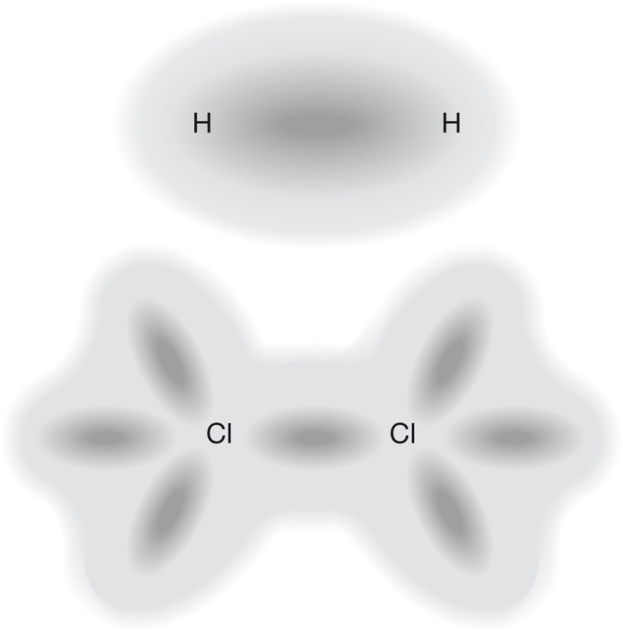
Charge cloud diagrams for hydrogen and chlorine molecules
Hydrogen chloride (HCl)
- ₁H electronic configuration:
- Needs ____ e⁻ for a stable outer shell
- Forms _____ covalent bond by sharing ____ e⁻
- ₁₇Cl electronic configuration:
- Forms ____ covalent bond by sharing ____, leaving ______ six non-bonding electrons and _____ non-bonding lone pairs.
Hydrogen chloride molecule

Molecules with more than two atoms
Water (H₂O)
In many covalent compounds, the atoms of the different elements require different numbers of electrons to gain stable outer-shells
Consider water, a compound of hydrogen and oxygen (H₂O):
- ₁H electronic configuration 1
- Needs 1e⁻ for a stable outer shell
- So forms one covalent bond by sharing 1e⁻
- ₈O electronic configuration 2,6
- Needs 2e⁻ for a stable outer shell
- So forms two covalent bonds by sharing 2e⁻, leaving four non-bonding electrons (two non-bonding lone pairs)
The atoms of both elements can obtain stable outer shells if two hydrogen atoms share electrons with each oxygen atom.
Water molecule

Ammonia (NH₃)
Ammonia (NH₃) is a compound of hydrogen and nitrogen.

Ammonia molecule

Some simple hydrocarbons
Methane (CH₄), ethane (C₂H₆) and propane (C₃H₈) are all found in natural gas. These compounds are generally known as hydrocarbons.

Methane (CH₄)

Ethane (C₂H₆)

Propane (C₃H₈)

Double and Triple Bonds
Oxygen (O₂): a molecule with double covalent bond
An oxygen molecule contains two oxygen atoms joined by covalent bonding. Its electronic configuration shows that it has a covalency of 2. This means it needs to share two of its valence electrons with two valence electrons from another atom or atoms.
A covalent bond formed by the sharing of two pairs of electrons between two atoms is called a double covalent bond.
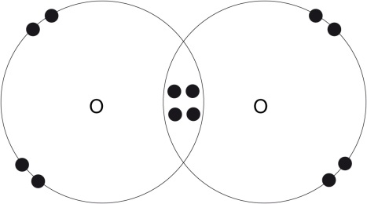
Nitrogen (N₂): a molecule with a triple covalent bond
Nitrogen has a covalency of 3 and therefore needs to share 3 valence electrons of its own with three electrons from another atom or atoms.
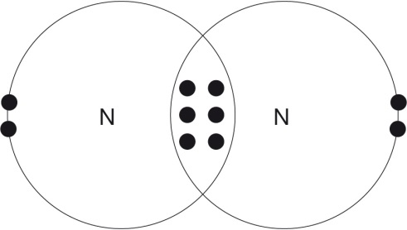
Ethane (C₂H₄)
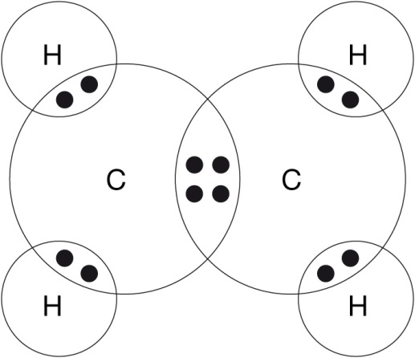

Representing Molecules
Chemists commonly use two types of diagrams to represent molecules:
- Electron dot formula
- Valence structures
In electron dot formulas, each of the outer-shell electrons is represented by a dot. Electrons taking part in the covalent bond are placed between the two atoms. Outer-shell electrons not involved or the non-bonding electrons are placed around the atoms in pairs.
In a valence structure, lines are used to represent electrons; one line represents one pair of electrons.
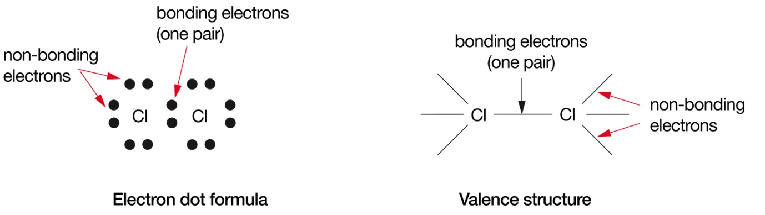
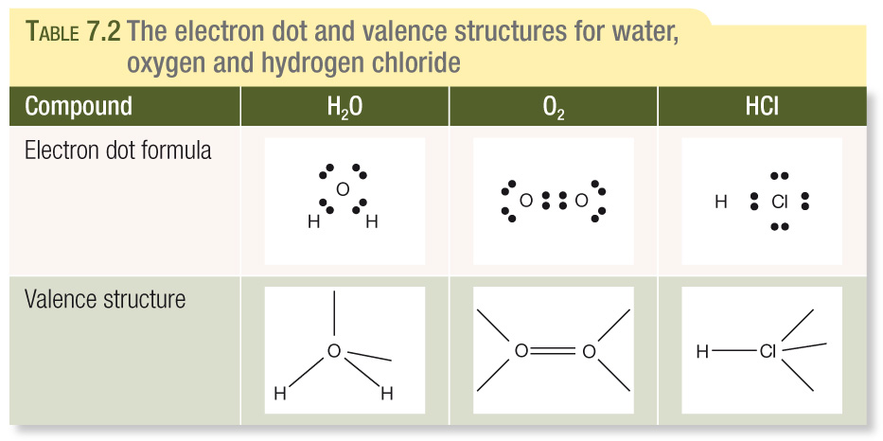
Draw the valence structure for nitrogen N₂:

Text Questions: 1 - 6

