7.4 Forces Between Molecules
All the bonding forces discussed so far (metallic, ionic and covalent) are electrostatic forces. They all involve the attraction between oppositely charged particles.
What is the main difference between all the bonding forces discussed so far?

Rub a plastic rod with nylon and place next to thin stream of water. Write your observations and thoughts on what you have observed happening on a molecular level.

Polarised Bonds
When two different non-metal atoms form a covalent bond, one atom usually attracts the bonding electrons more strongly than the other atom.
In a hydrogen chloride (HCl) molecule, the chlorine atom attracts the bonding electrons more strongly than the hydrogen atom. Chlorine is said to have a greater electronegativity than hydrogen.
This means that the bonding electrons spend more time closer to the chlorine atom than to the hydrogen. The chlorine end of the molecule becomes slightly negative and the hydrogen end slightly positive.
The chlorine atom has a partial (not whole) negative charge and the hydrogen has a partial positive charge.
The covalent bond in the hydrogen chloride molecule is said to be polarised and the, molecule itself is said to be a polar molecule. The molecule is also said to be a dipole, because it has two charged ends or poles.

Diagram representing a polarised bond

In solid hydrogen chloride, the molecules will be arranged so that oppositely charged ends of the dipoles are next to each other.
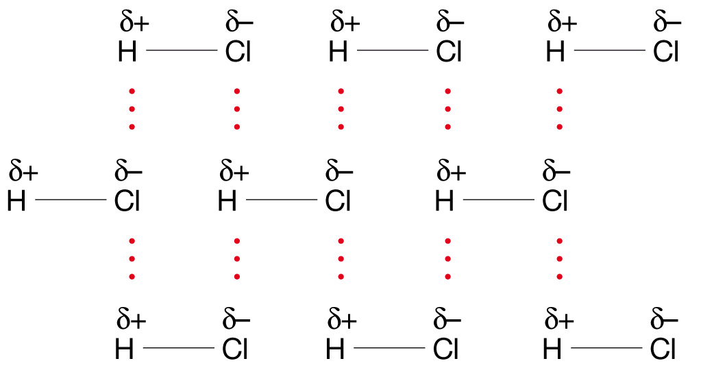
It is the electrostatic forces of attraction between the oppositely ends of the molecules that hold them together. This type of intermolecular force of attraction is called a dipole-dipole attraction.

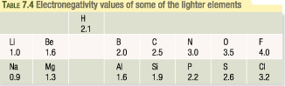
The electronegativity of an element is a measure of the relative attraction that the element has for electrons in a bond. It tends to increase left to right across a period and decrease down a group.
Intermolecular Forces and Melting.
Dipole –dipole attraction forces are strong enough to hold hydrogen chloride molecules together in a solid lattice at low temperatures.
When solid hydrogen chloride is warmed to its melting temperature (-114ºC), the molecules gain sufficient energy to overcome some of the forces of attraction and the lattice breaks up to form liquid HCl. The molecules themselves remain intact because of the strong covalent bonds between hydrogen and chlorine.
The dipole-dipole forces between the molecules have not disappeared, they are still there and they hold the molecules in the liquid state. Above the melting temperatures the forces are not strong enough to hold the molecules in rigid lattice.
Identifying Polar Molecules.
Valence structure for formaldehyde, carbon dioxide and tetrafluoromethane

Compare the structure of the three molecules above, all three of these have polarised bonds, but not all are dipole.
Two conditions must be applied if a molecule is to be a dipole:
- It must have polar bonds
- The partial charges must be distributed asymmetrically across the molecule, i.e. the molecule must not be symmetrical.
Which of three are polar and which non-polar?

Hydrogen Bonding
Hydrogen bonding occurs between molecules in which hydrogen is bonded to nitrogen, oxygen or fluorine. Hydrogen bonding is the most significant kind of dipole-dipole attraction.
Hydrogen bonding occurs because:
- Nitrogen, oxygen or fluorine are very electronegative atoms
- The bonds between hydrogen atoms and each of these other atoms are, therefore, highly polarised.
- There is a relatively large partial positive charge on the hydrogen atom when it is bonded to one of the three specific atoms.
- Nitrogen, oxygen and fluorine atoms each have at least one lone pair of electrons when they form molecules.
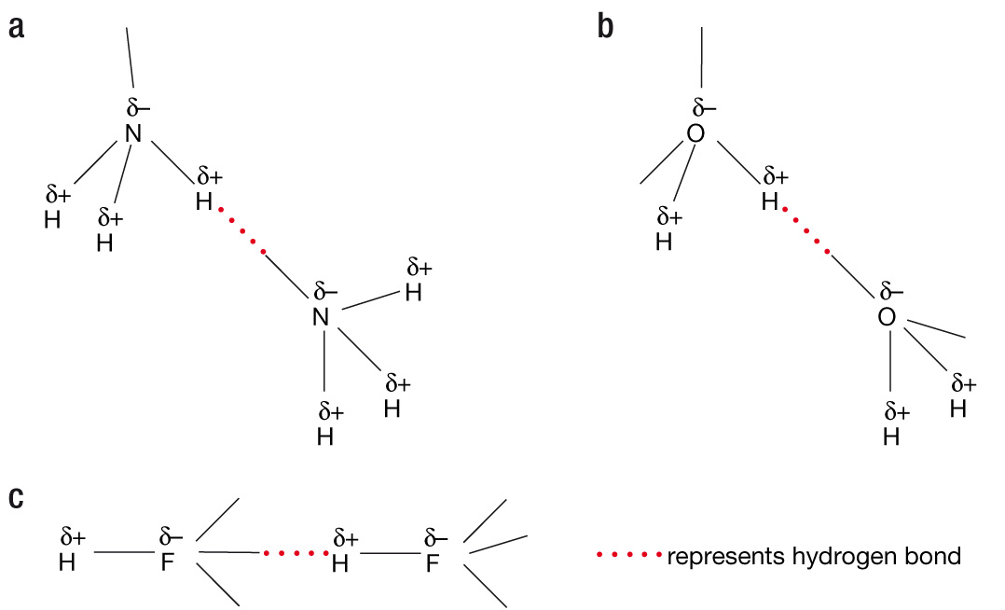
Hydrogen bonding has a special effect in water when it turns to ice. To give maximum attraction between the dipoles, the water molecules are spaced more widely apart in the solid than the liquid, which is why water expands when it freezes.
Remember:
- Hydrogen bonding is an intermolecular force.
- Only occurs from one covalent molecule to another, under the above conditions.
- Hydrogen bonding is much weak than ionic, covalent or metallic bonding.
- Hydrogen bonding is more significant than other forms of dipole-dipole attraction.
Weakest Bonding Forces
The weakest bonding force operates in all substance and is most important when it is the only force between particles.
It occurs as a result of the constant movement of electrons in atoms and molecules. It is highly unlikely that at a given point in time the electrons in an atom are distributed exactly symmetrically around the nucleus.
It is more likely that there are more electrons on one side than another. This causes the atom to become momentarily polar and so electrostatically interact with neighbouring atoms or molecules.
The electrons are moving rapidly and so the direction of these instantaneous interactions is rapidly changing.
These instantaneous dipoles result in a net, but weak, force of attraction between all particles.

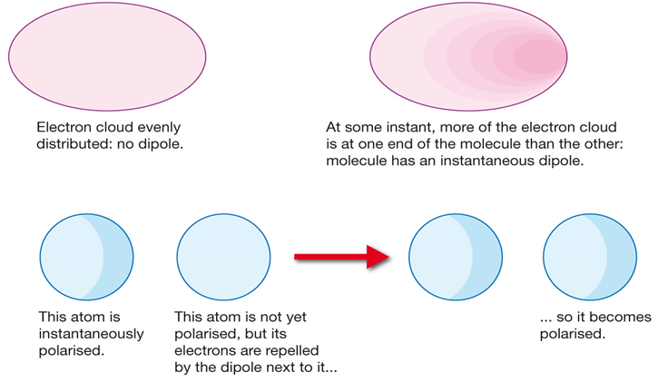

The noble gases rarely lose, gain or share electrons as they already have a particularly stable outer shell (8 electrons) and rarely combine with other atoms.
As elements, the particles present in solid, liquid and gases of noble gases are the individual atoms. The fact that liquid and solid states of these elements can be formed means there must be forces between the atoms.
The very low melting and boiling points indicate that this force must be extremely weak.
These forces are only considered when no significantly stronger forces exist.
They are known as dispersion forces or van der Waal’s forces and are responsible for holding the molecules together in non-polar molecular substances. Examples include molecular oxygen, hydrogen, nitrogen and methane, as well as the noble gases.

Text Questions: 9 – 15
Workbook: 18

