7.5 Covalent Lattices
Diamond and graphite form covalent bonds continuously throughout a lattice.
The structure of diamond is described as a network lattice.
The structure of graphite is described as a layer lattice.
These giant covalent lattices are solids at room temperature and require exceptionally high temperatures to melt. Note that neither diamond nor graphite actually melts but instead sublimes as all the covalent bonds are disrupted simultaneously.
Covalent Network Lattices
Diamonds are the hardest naturally occurring substance know.
In diamond, each carbon atom is covalently bonded to four others, with the bonding extended throughout the lattice and forms a tetrahedron shape. There are no weak links within these lattices.
Silicon, silicon carbide and silicon dioxide also form covalent network lattices.
Each silicon atom is covalently bonded to four other silicon atoms in a tetrahedral arrangement.
Silicon carbide (SiC), each silicon atom is bonded with four carbon atoms and each carbon atom bonded to four silicon atoms.
Silicon dioxide (SiO₂), each silicon atom is covalently bonded to four oxygen atoms and each oxygen atom is bonded to two silicon atoms, in a continuous, three dimensional lattice.
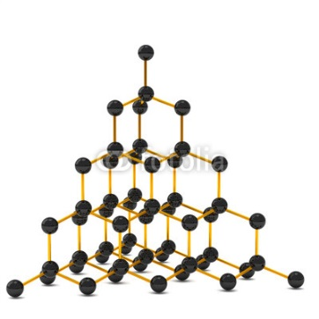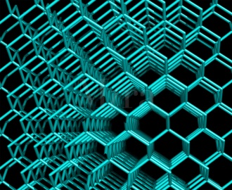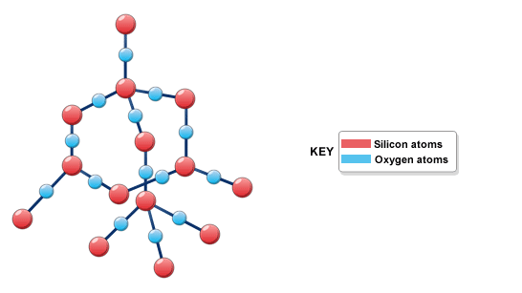

Graphite: a covalent layer lattice.
Graphite is very hard in one direction but quite slippery and soft in another direction.
Graphite has a layer structure. The carbon atoms within a layer are held strongly together by covalent bonds. The covalent bonds within a layer are very strong.
The forces between layers are weak dispersion forces and the structure of graphite is described as a covalent layer lattice.
Within each layer, each carbon atom is covalently bonded to three other carbon atoms. The fourth electron from each carbon atom is delocalised and it free to move within the layer. It is these delocalised electrons that enable graphite to conduct electricity.
Note also that the distance between the layers is much greater than the carbon-to-carbon bond length within the layer.

