8.1 Why is Carbon Important?
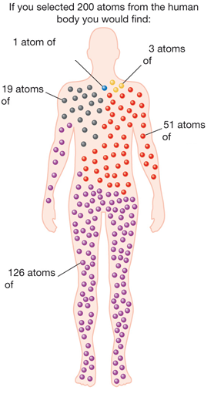
Carbon compounds make up over 90% of all chemical compounds and many form the basis of living systems. The study of carbon compounds is known as organic chemistry.
In its many millions of organic compounds carbon is associated with hydrogen and commonly oxygen, nitrogen, sulfur and chlorine.

