8.2 How Does Carbon Form So Many Compounds?
The electronic configuration of carbon is 1s²2s²2p². It can form a wide variety of compounds because:
- Each carbon atom has four valence electrons, all available for bonding with other atoms.
- A carbon atom can form strong covalent bonds with other carbon atoms.
- Bonds between carbon atoms can be single or multiple.
Natural Gas
Natural gas is often found with deposits of petroleum and are formed by chemical degradation of organic matter. With a lack of oxygen, over time, with heat and pressure this material is converted into many different compounds of carbon and hydrogen. These compounds are known as hydrocarbons.
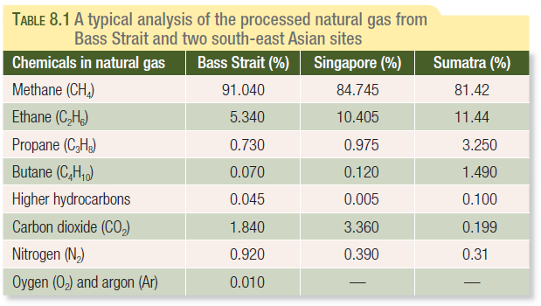
What are the common features of the chemicals listed?

