8.3 Hydrocarbons
Hydrocarbons can be classified into several series or families. The first series is called the alkane series.
Alkanes
Alkanes are a series of compounds that consist of carbon and hydrogen only (all hydrocarbons). Their other feature is that their molecules contain only single bonds.
Can you notice any pattern in the formulas of the first 10 alkanes list below?
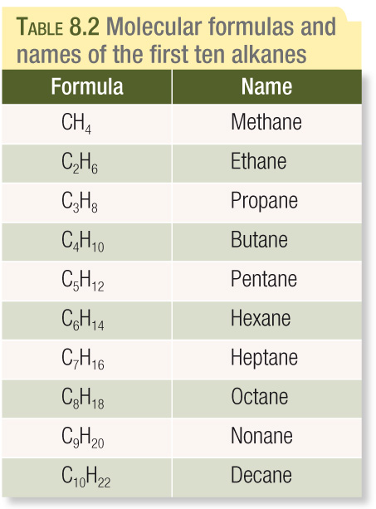

A series of compounds with similar chemical properties in which each member differs from the previous one by –CH₂ – is known as a homologous series.
Members of the same homologous series tend to have very similar chemical properties.
The alkanes have the general molecular formula:
C_{n}H_{2n+2}
Where n is an integer.
If a compound belong to the alkanes has 16 carbon atoms, then its molecular formula is:
Crude oil contains alkanes with n having values from 5 to 70. You can begin to see how the ability of carbon atoms to from covalent bonds with other carbon atoms enables a very large number of compounds to be formed.
Representing Alkane Molecules
We use structural formulas to represent hydrocarbons. They are very similar to valence structures (Chap 7). With structural formulas the focus is on the location of atoms relative to other atoms in the molecule as well as the number and location of chemical bonds.
Structural formulas representing the first three alkanes.

In each of these molecules:
- Each carbon atom forms a single covalent bond to four other atoms.
- Each hydrogen atom forms a single covalent bond to one other carbon atom.
- The four atoms bonded to each carbon atom are arranged in a tetrahedral shape.

Draw the structural formula for the molecule C₄H₁₀

There are two possible arrangements that satisfy the bonding requirements for each of the four carbon atoms and 10 hydrogen atoms.
The structure represented by a) has four carbon atoms bonded in a continuous chain. The overall molecular is linear and is sometimes called straight-chained molecules.
The structure represented by b) has four carbon atoms bonded in branched chain.
These two molecules are structural isomers of C₄H_{10.} Structural isomers are molecules with the same molecular formula but different arrangements of their atoms.
Structural isomers have similar chemical properties but differ in some physical properties such as melting temperature and boiling temperature.
As molecules become larger the number of possible arrangements increases rapidly. The alkane C₂₀H₄₂ has 366, 319 possible isomers.
The alkanes have all single bonds and are known as saturated hydrocarbons, because there are only single bonds between carbon atoms, they are saturated with hydrogen atoms.
Carbon and hydrogen can also form series of compounds in which there are double or triple bonds between carbon atoms.
Alkenes
Ethane has the molecular formula C₂H₄ and is the first member of the alkene series. All alkenes have one double bond present between two carbon atoms.
Structural formula of ethane

Molecular formulas and names of first nine alkenes.
Formula | Name
C₂H₄ | Ethane
C₃H₆ | Propene
C₄H₈ | Butene
C₅H₁₀ | Pentene
C₆H₁₂ | Hexene
C₇H₁₄ | Heptene
C₈H₁₆ | Octene
C₉H₁₈ | Nonene
C₁₀H₂₀ | Decene
As with alkanes, alkenes differ with successive molecules by –CH₂– and therefore the alkenes also form a homologous series.
The alkenes have the general molecular formula:

Representing Alkene Molecules
Propene (C₃H₆) has one carbon-to-carbon double bond.

Butene (C₄H₈) has more than one isomer.
The three possible alkene isomers for Butene.

We can summarise the structural formula without indicating the three-dimensional arrangement of atoms using a semistructural formula. The carbon atoms and the attached hydrogen atoms are listed in order in which they appear in the structural formula. Single bonds are not indicated but double and triple are. Groups of atoms that form branches are written after the carbon atom to which they are attached and place in brackets.
Write the semistructural formula for the three alkenes above.

Text Questions: 3 – 6

