8.4 Naming Hydrocarbons
To help distinguish between different compounds and isomers we have a naming system which is globally recognised.
This system provides a set of rules by which chemists can derive the systematic name for a given compound (or visa versa).
Straight-chained Hydrocarbons
In the systematic naming of straight-chained hydrocarbons, the first part of the name refers to the number of carbon atoms in one molecule.
No. of Carbon Atoms | Prefix
1
2
3
4
5
6
7
8
9
10

The name of the hydrocarbon ends in:
- ane if all carbon-to-carbon bonds are single bonds
- ene if one of the carbon-to-carbon bonds are double
- yne if one of the carbon-to-carbon bonds are triple
For example the compounds pentane, pentene and pentyne all have five carbon atoms bonded in a linear or straight line.

Unsaturated Compounds
To name straight-chained alkenes, first number the carbon atoms in the chain, starting at the end that will give the first carbon atom involved in the double bond the smallest number.
The two possible isomers of C₄H₈ are show below.
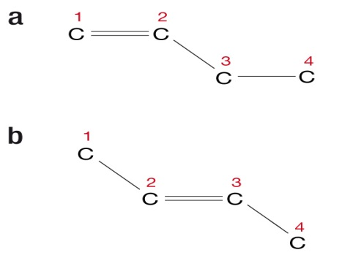
In isomer a) the numbering starts with one of the end carbon atoms involved in the double bond and the isomer is named according to the first carbon atom involved in the double bond. Therefor this isomer is called but-1-ene or 1-butene.
In isomer b) the double bond starts on the second carbon atom in the chain and hence is called but-2-ene (2-butene).
Branched Hydrocarbons
An alkyl group most often forms in a branched-chained hydrocarbon.
An alkyl group is a alkane molecule less one hydrogen atom and is named after the alkane group from which it is devired.
So –CH₃ is a methyl group, –C₂H₅ (–CH₂CH₃) is an ethyl group and –C₃H₇ (–CH₂CH₂CH₃) is a propyl group.

Text Questions: 7 – 8
Worksheet: 21

