8.5 Properties of Alkanes and Alkenes
As the number of carbon atoms increases, members of a homologous series show a gradual change in their physical properties.
Compounds with smaller molecules are more volatile (the liquids evaporate more easily), than those with larger molecules. Less energy is required to overcome the forces between the smaller molecules.
It is the vapour above the liquid that burns and so more volatile compounds will burn more rapidly.
These more volatile liquids also have lower viscosity. Viscosity is a measure of the ‘thickness’ of a fluid. Liquids with low viscosity flow more easily than those with higher viscosity.
Both petrol and oil are composed of a mixture of hydrocarbons.
Which has a lower viscosity?
Which is more volatile?
Which has larger molecules?

The boiling temperature of a hydrocarbon increases with the number of carbons in the molecule.
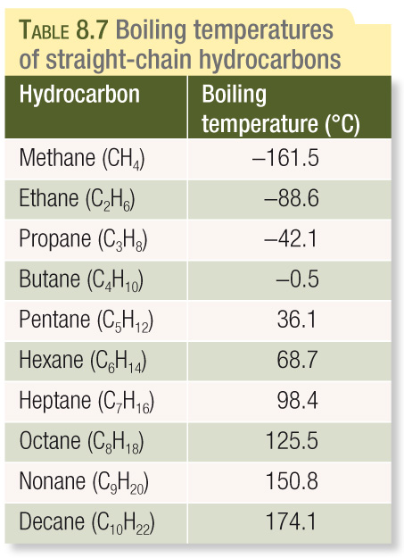
The physical properties of alkenes are very similar to those of alkanes.
Boiling temperature and viscosity increases with molecular size and volatility decreases with molecular size.
An alkane and an alkene with the same number of carbon atoms have similar boiling temperatures, with the alkene’s being slightly lower.
Boiling temperature of propene is -48ºC while propane’s is -42ºC.

Forces Between Hydrocarbons Molecules.

The bonding between the atoms of a hydrocarbon is:

As the electronegativies of carbon and hydrogen are very similar, the molecules of hydrocarbons are:

The forces between hydrocarbon molecules are therefore:

which increases in strength as the size of the molecule increases.
More energy is required to overcome the intermolecular dispersion forces between larger hydrocarbon molecules and so a higher temperature is required for them to boil.
The stronger the dispersion forces between molecules the lower the tendency for liquids to evaporate and so the lower the volatility.
The higher the viscosity of longer-chained hydrocarbons is due to the tendency of longer molecules to become ‘tangled’ together.

Chemical Properties of Alkanes.
The most significant reaction of alkanes in our society is combustion.
Alkanes burnt in oxygen release large amounts of energy for transportation, heat and the production of electricity. If the supply of the oxygen is sufficient, the products of the reaction are carbon dioxide and water.
Equations for Combustion Reactions
A chemical equation is a shorthand method of communicating the rearrangement of atoms in a chemical reaction.
The diagram below shows the reaction between methane and oxygen.
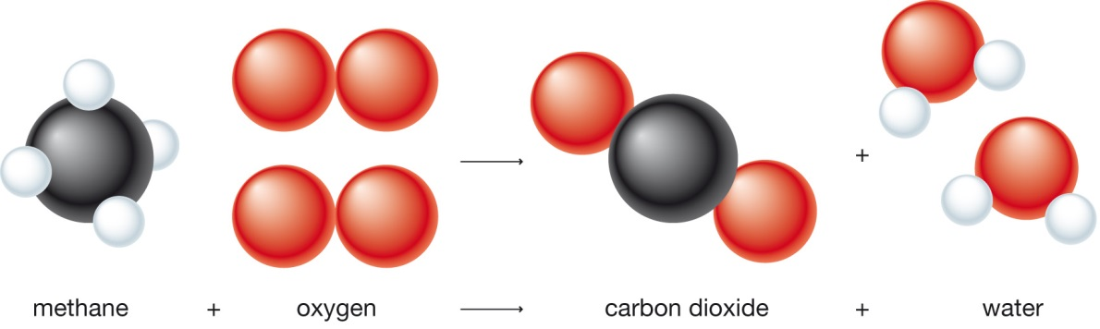
This is summarised by the chemical equation:
CH₄ + 2O₂ CO₂ + 2H₂O

Rules for Balancing Chemical Equations
Write the equation for the complete combustion of propane to give carbon dioxide and water.
- Identify the reactants and products. The reactants are written on the left-hand side of the equation. An arrow indicates the direction of the reaction:

- Write down the chemical formulas of the reactants and products

- Balance the number of carbon atoms on each side of the equation. The balancing is done by adding coefficients in front of the formula for an element or compound.

- Balance the number of hydrogen atoms on each side.

- Calculate the total number of oxygen atoms in the products and balance with the same number of oxygen atoms in the reactants.

- Include the states for the reactants and products.

Chemical Properties of Alkenes
Alkenes like alkanes, burn in oxygen to produce carbon dioxide and water with the release of heat. As alkenes have a double carbon-carbon bond, they tend to react more readily and with more chemicals, than alkanes.
Alkenes, in particular ethene and propene, are not used as fuels but rather as starting chemicals to manufacturing a large range of compounds such as alcohols, antifreeze and various kinds of plastic.
Apart from combustion, the reactions of ethene and alkenes in general, usually involve the addition of a small molecule to produce a single product.
Reactions of Ethene
- Reaction with Bromine solution
Ethane reacts with bromine solution (Br₂ – dissolved in an organic solution). It involves what is known as an addition reaction, bonding ‘new’ atoms to the two C atoms on either side of the double bond, which converts the C=C double bond to a carbon-carbon single bond.

- Reaction with Hydrogen gas
In the presence of a catalyst and on heating, ethene reacts with hydrogen gas to produce ethane. A hydrogen atom has bonded to each of the carbon atoms on either side of the double bond, converting the C=C to carbon-carbon single bonds.

- Reaction with Steam.
Large amounts of ethanol are made by the addition reaction of steam and ethene using a phosphoric acid catalyst.

- Formation of Polyethene.
An edition reaction of ethene and ethene is involved in making polyethene. The double bonds are still converted to single bonds but no other reactant is added. The ethene molecules themselves are joined together to form a long chain.

Polyethene is usually written as (-CH2-CH2-)_{n} , where n represent a large number. The number in this reaction is very large – 10,000 or more. A molecule linking a large number of small molecules is called a polymer (many units), the small molecule, ethane, is called the monomer (one unit). The name polyethene means many units of ethene.
This type of reaction is known as addition polymerisation.

Text Questions: 9, 10, 11
Worksheet: 20

