8.6 & 8.7 Polymers
Polymers are characterised by the size of the molecules, each one often containing tens of thousands of atoms. Cotton and wool are examples of naturally occurring polymers and then there are the synthetic polymers that are widely used today.
The term plastic is often used to describe these materials. As chemists the word ‘plastic’ describes a property not a product. A substance is described as plastic if it can be moulded in different shapes readily. Polymers can be both plastic (ice-cream container) and non-plastic (power points).
Polymers: What are They?
- Polymers are very large covalent molecular substances containing tens of thousands of atoms.
- They are formed by joining many small molecules called monomers.
- This process is called polymerisation.
There are two types of polymerisation:
- Addition and
- Condensation (not discussed)

Addition Polymers
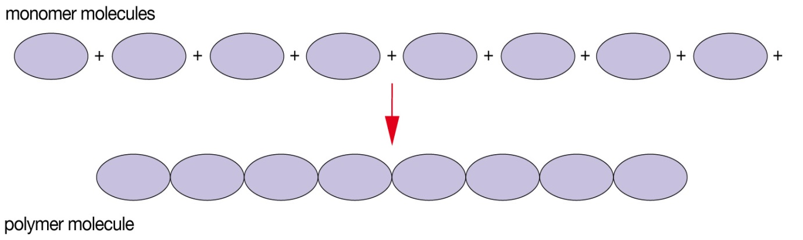
Covalent bonds form between the monomer molecules to produce a polymer molecule.
Suitable monomers for addition polymerisation are unsaturated molecules. The double bonds between the two carbon atoms react and new covelant bonds are formed between carbon atoms of nearby molecules to form long chains.
Polyethene
The polyethene molecules have a backbone of carbon atoms, on averge, 150,000 atoms long in each chain. Polythene is the simplest of polymers because only hydrogen atoms are bonded to the carbon atoms in the chain.
It is a thermoplastic polymer as it can be heated again and reshaped. This is because the bonds between the non-polar chains are weak dispersion forces and when heated can slide past each other. The strong covalent bonds are unaffected.
There are two different forms of polyethene:
- High-density polyethene – polymerisation at atmospheric pressure using a metal oxide catalyst at about 310ºC. Monomers join in continuous chains with very few branchings and can pack close together
- Low-density polyethene – polymerisation at high pressure, with oxygen and a temperature of 300ºC. Polymer chains are high branched and not packed closely together.
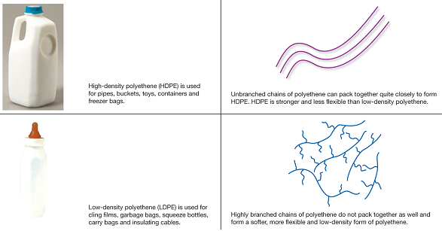

Other examples of addition polymers are shown in the table 8.9 (page 156). The monomers are similar to an ethene molecule except one or more the hydrogen atoms has been replaced by a different atom or group of atoms. This produces polymers with different properties and uses.
Types of Polymers
Type of Polymer | Structure | Properties | Applications
Thermoplastic | Strong covalent bonds within chains  Weak forces between different chains. | Flexible  Soften on heating | Items produced by moulding  e.g. laundry baskets, milk bottle, toys
Thermosetting | Strong covalent bonds within chains  Strong covalent bonds called cross-links, between different chains | Does not melt but char when heated  Rigid | Laminates
Elastomer | Strong covalent bonds within chains  Small number of cross-links between different chains | Elastic – can be pulled out of shape but will regain original shape when force is removed | Rubber

Synthesis of Cross-links
Thermosetting molecules require a second stage of production in which cross-links are formed. This is achieved by:
- Heating the material after the polymer chains have been formed
- Adding another substance that reacts with the atoms on the chains, joining the chains together.
A cross-link is a covalent bond between polymer chains. The more cross-links between chains the more rigid the polymer. The strong covalent bonds in three dimensions bind all the atoms together to form one large lattice.
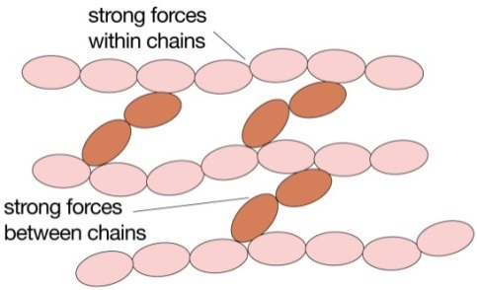
Customised Polymers
Customised polymers are polymers designed and manufactured for a particular task or application. The physical and chemical charateristics of polymers may be improved by one of the following:
- Using two different monomers to make copolymers, which can exhibit a combination of the properties of the pure polymers.
- Altering the structure of side groups
- Changing the arrangement of side groups
- Using additives.

Text Questions: 12 – 16
Worksheet: 23
Chapter Review: 17 - 38

