9.1 An Overview of Bonding
All chemical bonding is electrostatic in nature. The strength of chemical bonding depends on the balance between the attraction between unlike charges and the repulsion between the charges:
- Metallic bonding results from the electrostatic attraction between cations and delocalised electrons
- Ionic bonding results from the electrostatic attraction between cations and anons
- Covalent bonding results from the electrostatic attraction between shared electrons and the nuclei of the atoms involved in the bond
Predicting the type of Bonding in a substance
To determine the type of bonding that occurs within a substance, we need to consider the following:
- What type of elements are involved?
- Are the outer-shell electrons:
  - Free to move (delocialised as found in metallic lattices)?
  - Donated from one atom to another atom (or group of atoms), creating ions (as found in ionic lattice)?
  - Shared between atoms (as found in covalent bonding)?
- Are the particles present ions, atoms or molecules?

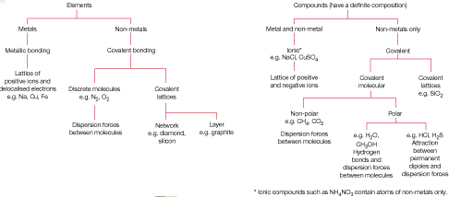
Worked Example 9.1a
Identify the bonding in each of the following substances in their solid state:
- Copper
Type of elements:
Type of particles:
Type of lattice:

- Copper sulfate
Type of elements:
Type of particles:
Type of lattice:

- Carbon dioxide
Type of elements:
Type of particles:
Type of lattice:

- Hydrogen bromide
Type of elements:
Type of particles:
Type of lattice:

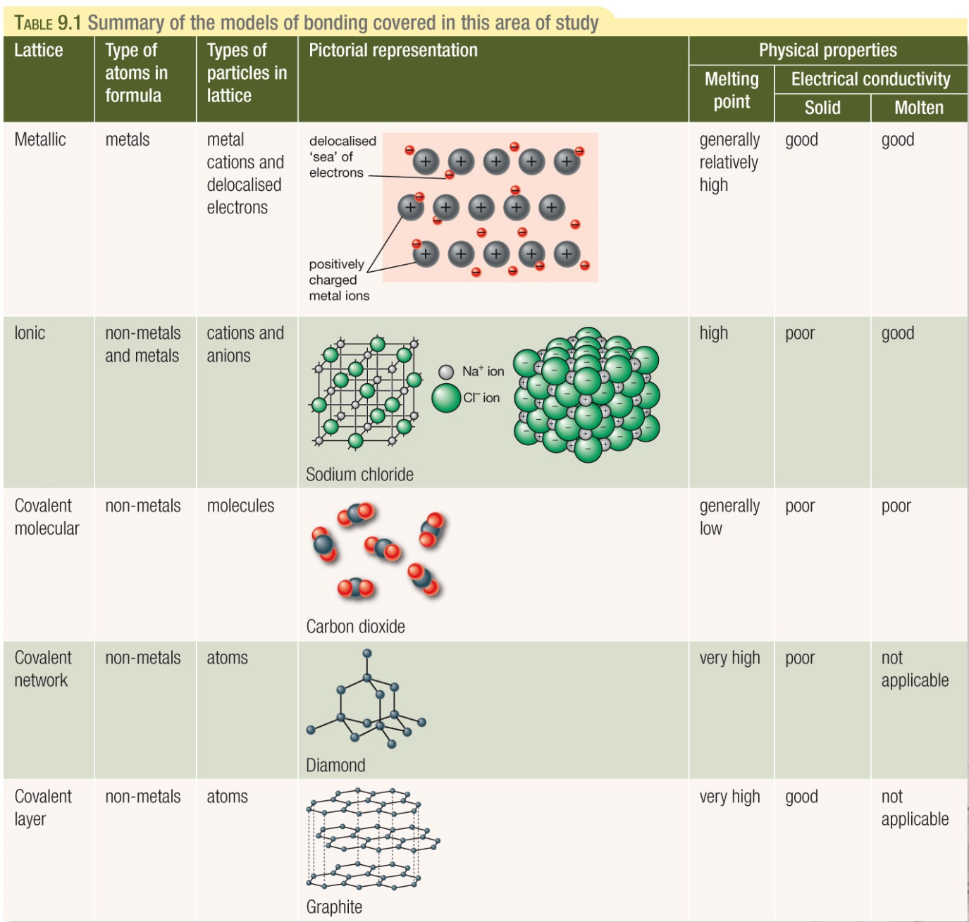
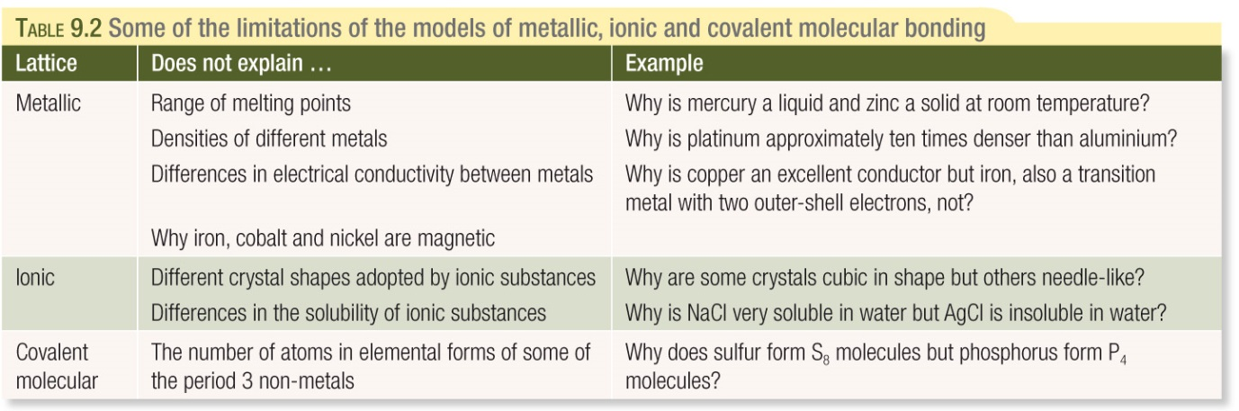
Text Questions: 1 & 2

