9.2 Surfaces of Materials
A surface or interface is the boundary between one substance and another.
In all models looked at so far concerning bonding, we have looked at particles in the interior of materials. What happens to the bonding on the edge or interface of a material?
What determines surface properties?
Particles at the surface of a substance are not completely surrounded by other particles of that substance.
Those atoms and ions at the surface of a substance are said to have incomplete bonds.
In a sodium chloride crystal, a chloride ion in the interior will be attracted to, and surrounded by, six sodium ions. A chloride ion on the surface, however, is only attracted to five sodium ions.
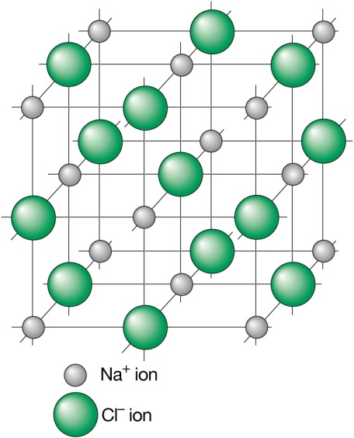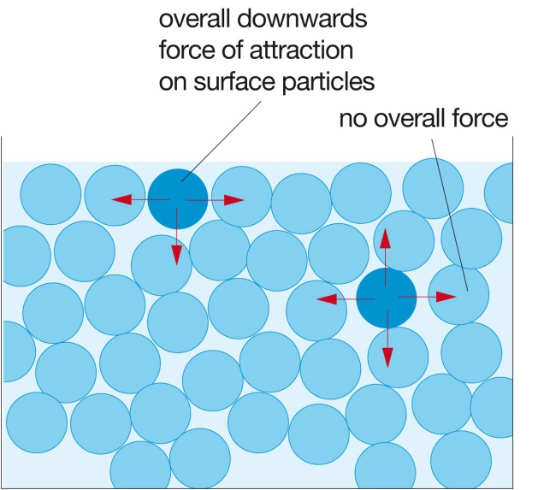
The molecules in water experience a sideways force of attraction to neighbouring molecules. These forces will be equal and acting in opposite directions so there is no net force. All molecules at the surface, however, experience attraction to the molecules below them, a pull towards in the interior of the surface. The surface of water, or any liquid, is in a constant state of tension.
The tendency of molecules to move away from the surface of a liquid means that a liquid will tend to form droplets. In space drops of liquid are perfectly spherical. A sphere is the shape with the least surface area for a given volume. More particles are completely surrounded by other particles and so are able to form the maximum number of bonds. The number of molecules at the surface with ‘incomplete bonds’ is kept to a minimum.
Surface Energy
The surface energy is the amount of energy needed to increase the surface area of a liquid by a specified amount. The surface energy will be related to the strength of the forces between particles and reflects the strengths of the bonds that must be broken to create a new surface.
Wetting
You probably have noticed that water behaves differently when placed on different surfaces. Water placed on glass will tend to spread out over glass but will form drops on plastic. We say that it wets the glass, glass is ‘water-loving’ or hydrophilic. Plastic is ‘water-fearing’ or hydrophobic.
If we consider the forces acting on the liquid particles that are in contact with the solid surface we can see that these particles are:
- Attracted to the bulk of the liquid
- Attracted or absorbed to the solid
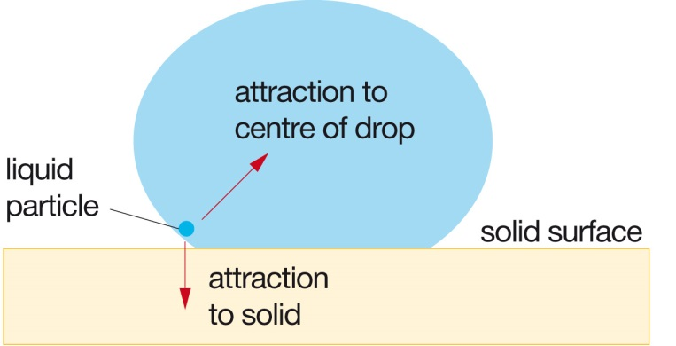
If the particles are much more strongly attracted towards the solid than towards the liquid, the liquid will tend to spread out. Conversely if attraction to the centre of the liquid is much stronger than towards the solid, the liquid does not wet the solid and forms drops.
Wetting is likely to occur if the solid has a higher surface energy than the liquid.

Text Questions: 3 - 6

