9.3 Nanoparticles
Size
The prefix ‘nano’ means a factor of 10⁻⁹ or one-billionth. So the term nanometre mean one billionth of a metre or 10⁻⁹ m. Nanoparticles are therefore extremely small. Their diameter typically ranges from 1 to about 100 nm.
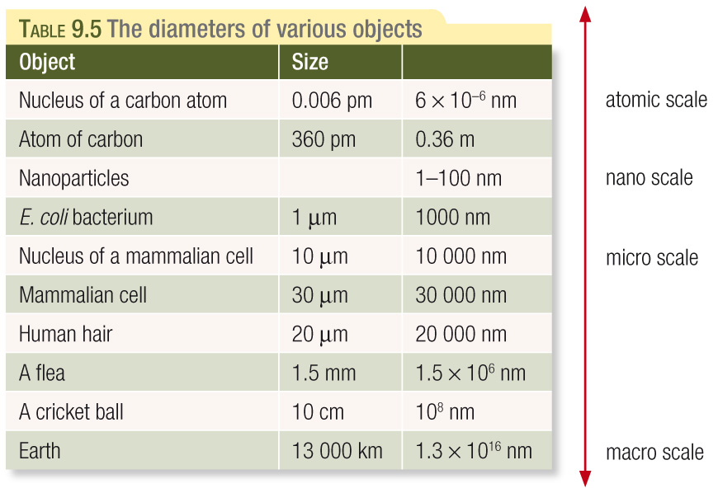
The way nanoparticles behave is directly related to their small size.
The nature of the surface becomes particulary important when the particle is small. If you have a 1m x 1m x 1m cube, the surface area is _____ and the volume is _______. Imagine that same cube is cut up into eight cubes (0.5m x 0.5m x 0.5). The new surface area is doubled (_______) but the volume remains the same. You could keep cutting up the cup into smaller and smaller cubes and each time the surface area would increase without the overall volume changing. As the surface area increases, the properties of the surface area become more significant.
The properties of minute particels such as nanoparticels differ from large ones because of their high surface area to volume ratio. Some of the examples of the influence of large surface areas include:
- Catalysis. When solids are used as catalysts, the reaction takes place on the caalyst’s surface. Nanoparticles with their high surface area to volume ratio make very effective catalysts.
- Surface Effects. With a large surface area, surface effects like friction have a higher impact.
Text Questions: 7 & 8
Worksheet: 22
Chapter Review: 9 – 13, 16, 17
Area of Study Review Multichoice: 1 – 20
Short-answer: 21 - 31

